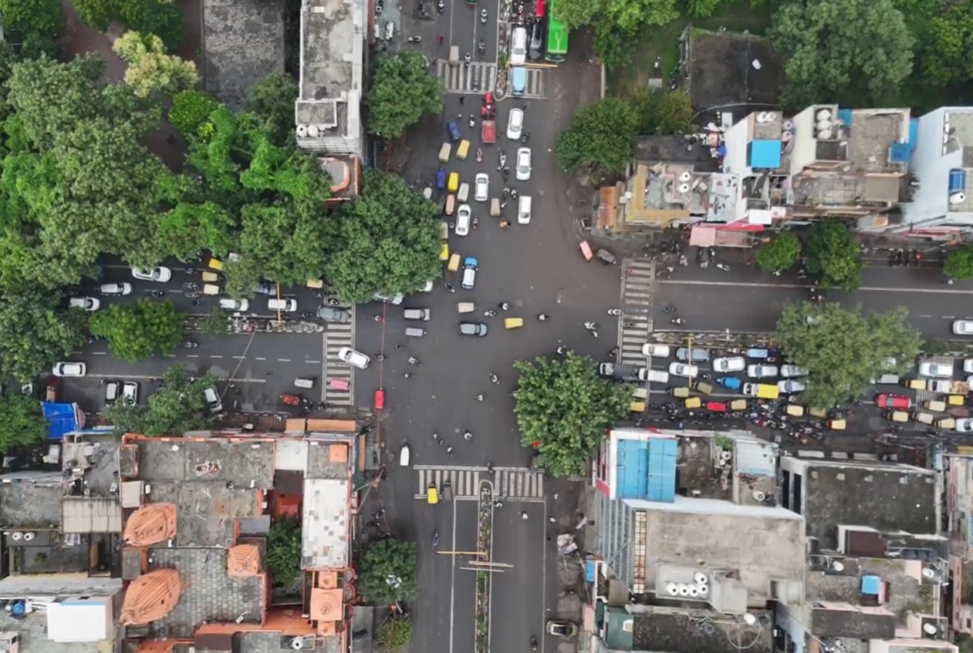



dELHI SHAHDARA DISTRICT ROAD SAFETY REPORT



**Report by:**



**Data support by:**

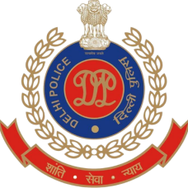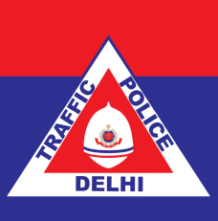

**Supported by:**







Table of Contents

List of Figures and Tables 1

List Of Abbreviations 3

Key Highlights 5

Introduction 6

Methodology 7

About the District 8

A : Road safety situation and trends in Shahdara district 9

A.1 : Road crash death trends 9

A.1.1 : Fatal road crashes and fatalities trend. 9

A.1.2 : Road crash fatalities by road user types 10

A.1.3 : Road crash deaths by month 11

A.1.4 : Road crash deaths by time and day of week 12

A.2 : Road crash deaths by age and gender 13

A.2.1 : Road crash deaths by gender 13

A.2.2 : Road crash deaths by age-groups and gender 13

A.3 : Road crash deaths by road user type 14

A.3.1 : Total Road crash deaths by road user type (2019, 2021, 2022) 14

A.3.2 : Timewise Road crash deaths by Road user type 15

A.3.3 : Who-hit-whom matrix 16

A.4 : Hit-and-runs in fatal road crashes 17

A.4.1 : Percentage of hit-and-run and non-hit-and-run cases 17

A.4.2 : Hit-and-run Road user types 17

A.5 : Road Crash Heatmaps 18

A.5.1 : Heatmap of all road crash deaths 18

A.5.2 : Heatmap of all pedestrian deaths 18

A.5.3 : Heatmap of all motorcycle (rider + pillion) related deaths 19

A.6 : High Risk Locations 20

A.6.1 : List of high-risk locations 20

A.6.2 : Map of all high-risk locations 20

A.6.3 : High risk corridors 21

B : Data to Action 22

B.1 : metro store seelampur intersection 22

B.1.1 : General Description of the site 22

B.1.2 : Existing Land Use 22

B.1.3 : Conflict Points 23

B.1.4 : Existing Scenario 23

B.1.5 : Issues Identified 24

B.1.6 : Proposed Design 26

: Summary budget estimates 27

B.2 : Durgapuri Chowk 32

B.2.1 : General description of the site 32

B.2.2 : Existing Land Use 32

B.2.3 : Existing Scenario 33

B.2.4 : Issues identified 33

B.2.5 : Proposed Design 34

B.2.6 : Summary budget estimates 36

B.3 : Safe School Zone: Government Boys Senior Secondary School (GBSSS), Vishwas Nagar 41

B.3.1 : General description of the site 41

B.3.2 : Existing Scenario 42

B.3.3 : Issues identified 43

B.3.4 : Activity map 45

B.3.5 : Proposed design 47

B.3.6 : Summary budget estimates 50

# 

# List of Figures and Tables

Figure 1 : Shahdara district map 8

Figure 2 : Fatal Road crashes and fatalities trend 9

Figure 3 : Road crash fatalities by road user types 10

Figure 4 : Average Road crash deaths by months 11

Figure 5 : Road cash deaths by gender 13

Figure 6 : Road crash deaths by age groups and gender 13

Figure 7 : Road crash deaths by road user type (2019, 2021, 2022) 14

Figure 8 : Timewise Road crash deaths by road user types 15

Figure 9 : Percentage of hit-and-run and non-hit-and-run cases 17

Figure 10 : Hit-and-run Road user types 17

Figure 11 : Heatmap of all road crash deaths in Shahdara district 18

Figure 12 : Heatmap of all pedestrian deaths due to road crashes in Shahdara District 18

Figure 13 : Heatmap of all motorcycle related deaths due to road crashes in Shahdara District 19

Figure 14 : Map of all high-risk locations intervened in Shahdara District 20

Figure 15 ; Vulnerable Road users on corridors 21

Figure 16 : Vulnerable Road users’ death per km 21

Figure 17 : Metro Store Seelampur Intersection satellite image 22

Figure 18 : Existing land use around Metro Store Seelampur Intersection 22

Figure 19 : Conflict points at Metro Store Seelampur Intersection 23

Figure 20 : Existing scenario of Metro Store Seelampur Intersection 23

Figure 21 : Issues identifies at Metro Store Seelampur Intersection 24

Figure 22 : Proposed design for Metro Store Seelampur Intersection 26

Figure 23 : Durgapuri Chowk Intersection satellite image 32

Figure 24 : Existing land use near Durgapuri Chowk Intersection 32

Figure 25 : Existing scenario at Durgapuri Chowk Intersection 33

Figure 26 : Issues identified at Durgapuri Chowk Intersection 33

Figure 27 : Proposed design for Durgapuri Chowk Intersection 34

Figure 28 : Land Use Map of Govt. Boys Senior Secondary School, Vishwas Nagar (AY 22-23) 41

Figure 29 : School Travel Data 42

Figure 30 : Site Photographs : Govt. Boys Senior Secondary School - School traffic with students walking between vehicles and walking on insufficient footpaths at Maharishi Valmiki Marg and Gurudwara Road 43

Figure 31 : Activity mapping at Govt. Boys Senior Secondary School Vishwas Nagar Afternoon 45

Figure 32 : Proposed Render of Maharishi Valmiki Marg in front of Govt. Boys Senior Secondary School Vishwas Nagar 48

Figure 33 : Proposed School Zone Plan for GBSSS Vishwas Nagar 49

Table 1 : Road crash deaths by time and day of week 12

Table 2 : Who-hit-whom matrix 16

Table 3 : List of high-risk locations 20

# List Of Abbreviations

* **GNCTD** Government of National Capital Territory of Delhi
* **DM** District Magistrate
* **DMRC** Delhi Metro Rail Corporation
* **DRSC** District Road Safety Committee
* **DTC** Delhi Transport Corporation
* **DTP** Delhi Traffic Police
* **FIR** First Information Report
* **FOB** Foot Over Bridge
* **GIS** Geographic Information System
* **GT** Grand Trunk
* **HV** Heavy Vehicle
* **IACP** International Association of Chiefs of Police
* **IIT** Indian Institute of Technology
* **IPC** Indian Penal Code
* **IRC** Indian Road Congress
* **iRAD** Integrated Road Accident Database
* **ISBT** Inter State Bus Terminal
* **KM** Kilometre
* **LMV** Light Motor Vehicle
* **MACT** Motor Accident Claims Tribunal
* **MCD** Municipal Corporation of Delhi
* **MoRTH** Ministry of Road Transport and Highways
* **MPD** Master Plan for Delhi
* **MTW** Motorised Two-Wheeler
* **NCR** National Capital Region
* **NCT** National Capital Territory
* **NGO** Non-Governmental Organisation
* **NH** National Highway
* **NHAI** National Highways Authority of India
* **NIC** National Informatics Centre
* **NSP** Netaji Subhash Place
* **PCR** Police Control Room
* **QGIS** Quantum Geographic Information System
* **RSLA** Road Safety Lead Agency
* **SKV** Sarvodaya Kanya Vidyalaya
* **SOP** Standard Operating Procedure
* **TRIPC** Transportation Research and Injury Prevention Centre
* **UT** Union Territory
* **WHO** World Health Organisation

# Key Highlights

* Fatal road crashes increased from 70 to 89 from 2021 to 2022.
* Pedestrians comprised 52.5% of the fatalities and motorcyclists comprised 32.8% of the fatalities in 2022.
* A large number of fatal crashes occurred between 2200 to 0600 hours.
* Two out of three fatal crashes( 66 %) are hit-and-run cases.
* A large number of fatal crashes involving  pedestrians and motorcyclists were hit and run cases.
* The high-risk locations of the Shahdara District are Metro Store Seelampur Intersection and Durgapuri Chowk.

# Introduction

There has been an increase of road crash fatalities in Delhi since the easing of pandemic mobility restrictions. Vulnerable road users such as pedestrians, two-wheeler occupants and three-wheeler occupants are most at risk of severe injuries and - in worst case scenarios - death in a road crash. This risk which hinders the basic right of mobility for the road users warrants that effective and evidence-based road safety interventions and programs must be implemented regularly and systematically to mitigate the effects of road crashes.

In the year 2023, the Transport Department released the ‘Data to Action’ report which analysed 2019 to 2021 data and identified high-risk locations for each of the eleven districts in Delhi. The report provided detailed maps, overall analysis for the National Capital Territory (NCT) of Delhi, and general recommendations for each district. The report was presented to the District Road Safety Committees (DRSCs) to guide them in implementing road safety interventions and address the most urgent road safety risk factors in their jurisdictions. The DRSCs take the lead in drafting the district road safety plan. They are instrumental in planning road safety interventions for high-risk locations in the district, implement interventions on the ground, and disburse road safety funds.

As a next logical step, to take evidence-based action in order to reduce crashes, the Transport Department are producing highly customised district specific road safety reports (DRSR) for the DRSCs. These reports include detailed findings on road crashes in the given district including a list of high-risk locations and provide specific recommendations to reduce crashes. The purpose of these DRSR is to guide DRSCs in implementing evidence-based interventions to reduce crash fatalities in high-risk locations and provide detailed infrastructure designs for specific locations which can be readily implemented on ground. The ultimate goal of this process is to inform and train the DRSC members in replicating the evidence-based action in the future.

# Methodology

Data Source

The District Road Safety Report (DRSRs) focused on road crash fatalities’ data in the National Capital Territory (NCT) of Delhi from the years 2019, 2021 and 2022. The data source for this report is police crash data records from the Motor Accident Claims Tribunal (MACT) cells of the Districts. In addition, this data is supplemented by the FIR lists from the Delhi Traffic Police. The dataset was compiled, digitised, and cleaned at the Transport Department.

Data Analysis

The digitised datasets were compiled and analysed using MS Access to produce descriptive statistics and were mapped using Quantum Geographic Information Systems (QGIS) platform, to identify high-risk locations including high-risk corridors in each district. Similar process will be followed for producing district road safety reports for the remaining districts.

On-site Investigation of High-risk Locations and Corridors

An in-depth and on-site investigation was conducted for the identified high-risk locations. At the site, both qualitative and quantitative data were collected which informed the design of the interventions. The data collection was based on the following parameters:

* Inspection of the road infrastructure and land use at the site.
* Identification of hazards and conflict points, especially pedestrians’ movement, bus stop locations.
* Assessment of the type and quality of enforcement
* Observations on road user behaviour, parked vehicles, street vendors and accessibility of vulnerable road users
* Identification of types of road users and traffic mix and speed.

These data points were collated and presented for the selected high-risk sites, and were used to inform the design of the proposed interventions.

Report Structure

Each district has a dedicated report. There will be a total of 11 reports - one for each district in NCT Delhi. The report is divided into three parts. The first part includes the introduction of road safety in the context of the district, and methodology that was followed to produce the report. The second part covers the discussion on the road safety situation in the given district. Finally, the last part of the report provides detailed investigation and recommendations for the selected high-risk sites in the district.

# ABOUT THE DISTRICT

The District of Shahdara, Delhi is located near the banks of River Yamuna. It is close to Chandni Chowk in Central Delhi as well as to Ghaziabad, Uttar Pradesh. It has an elevation of 239 Mtrs. above sea level.

Area: 35sqkm

Villages and Panchayats: 6

Tehsils: 3

Subdivisions and blocks: 3

Constituencies: 3

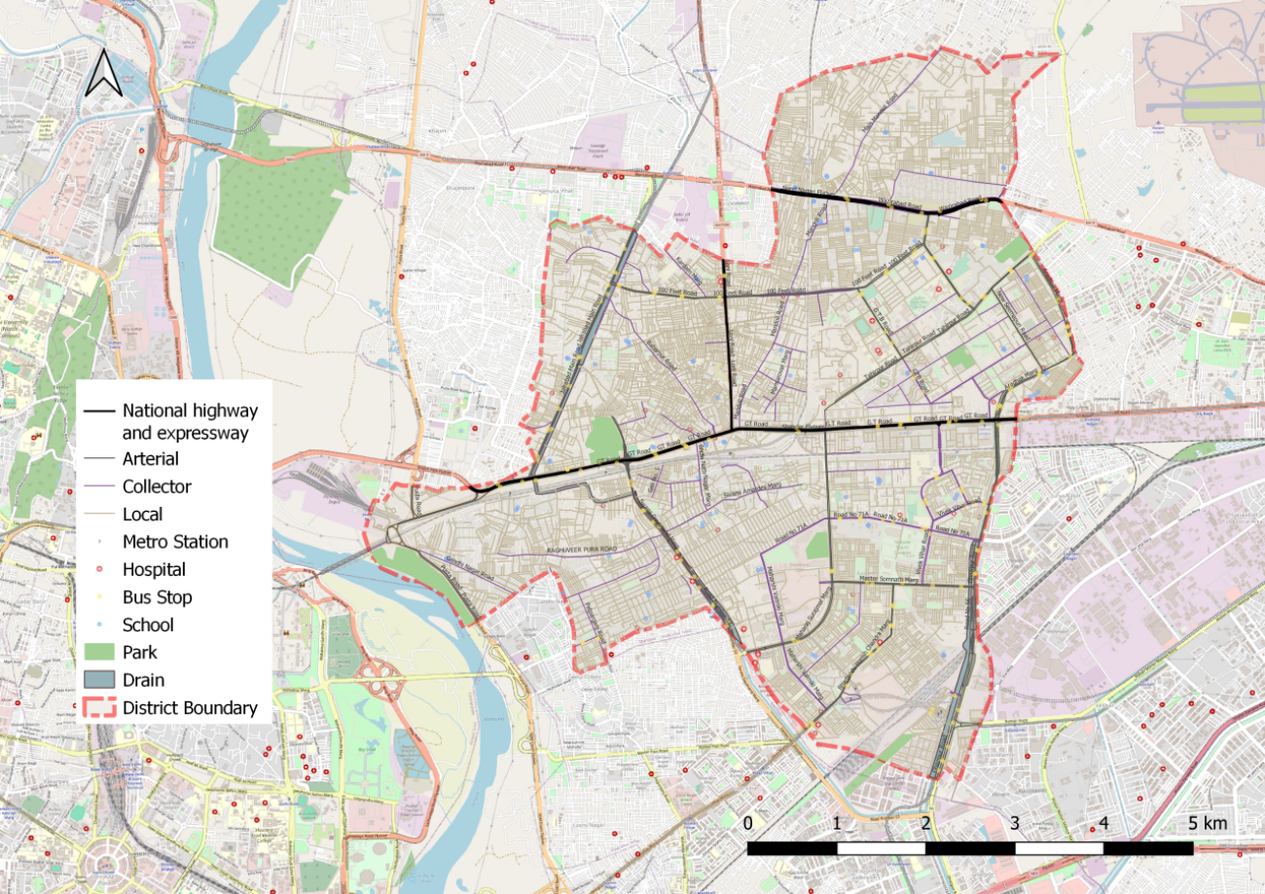

Figure 1: Shahdara district map

# **: Road safety situation and trends in SHAHDARA district**

## : Road crash death trends

### : Fatal road crashes and fatalities trend.

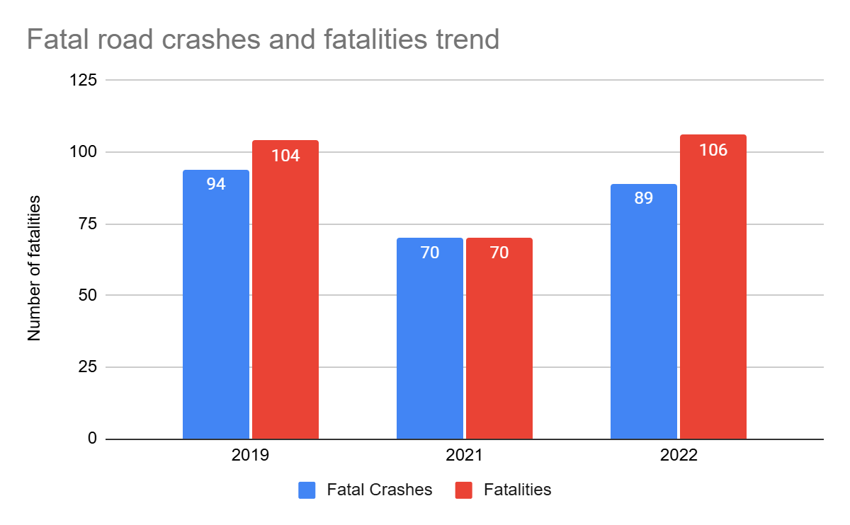

Figure 2: Fatal Road crashes and fatalities trend

There were 89 fatal road crashes in the Shahdara District of Delhi in 2022 with 106 persons killed in these crashes. There is a 27% increase compared to the previous year 2021 which is 70. One person is killed in road crashes in the Shahdara District every three to four days.

### : Road crash fatalities by road user types

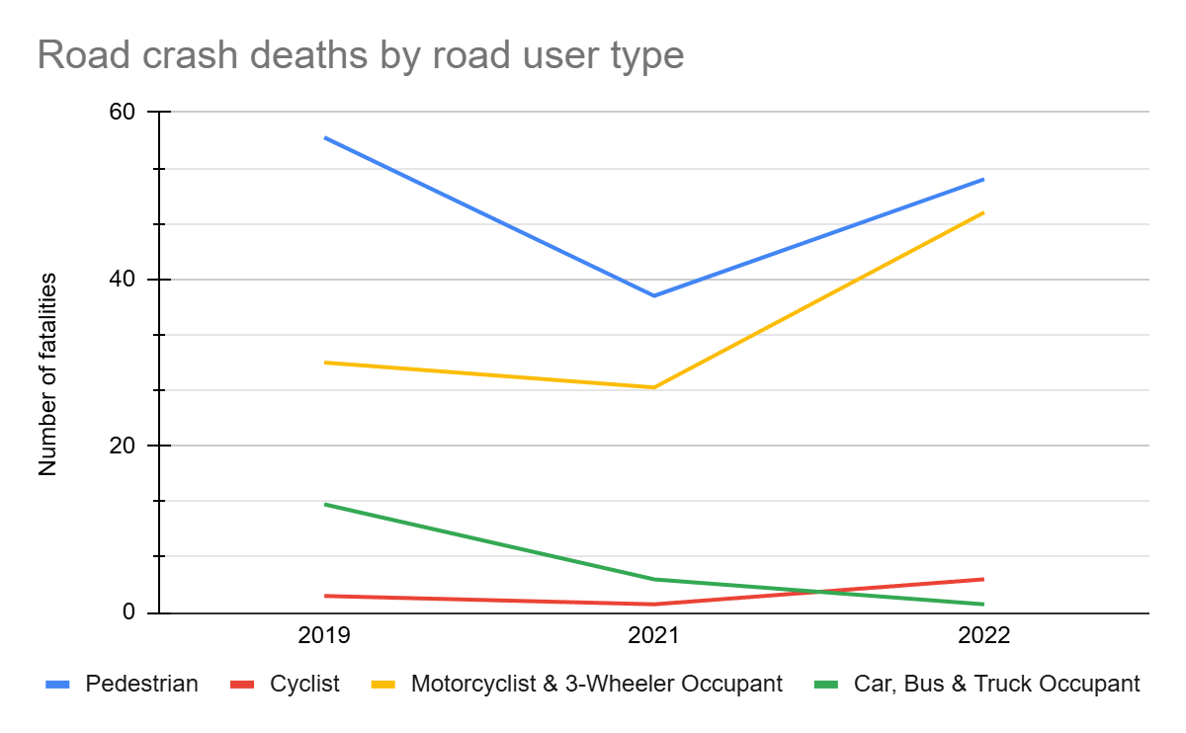

Figure 3: Road crash fatalities by road user types

Motorcyclists, auto rickshaw occupants and pedestrians formed a majority of persons killed in road crashes in the Shahdara District across all three years. Between the highlighted categories, the pedestrians’ fatalities surpassed the motorcyclist and autorickshaw occupants’ fatalities in all the years.

### : Road crash deaths by month

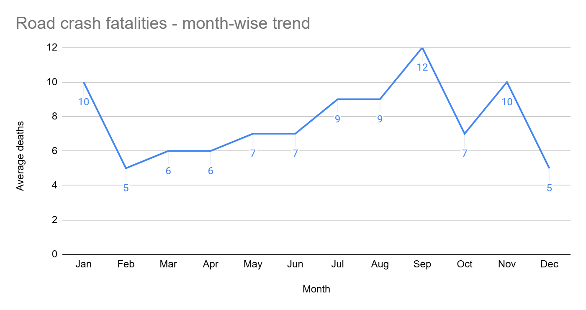

Figure 4: Average Road crash deaths by months

September, January,and November witnessed the highest number of persons killed followed by July and August, there is no discernible pattern of fatalities by month.

### : Road crash deaths by time and day of week

|  |  |  |  |  |  |  |  |  |
| --- | --- | --- | --- | --- | --- | --- | --- | --- |
|  | **Monday** | **Tuesday** | **Wednesday** | **Thursday** | **Friday** | **Saturday** | **Sunday** | **Total** |
| **02:00-06:00** | 9 | 6 | 6 | 4 | 9 | 7 | 10 | **51** |
| **06:00-10:00** | 4 | 5 | 2 | 6 | 2 | 8 | 5 | **32** |
| **10:00-14:00** | 5 | 4 | 7 | 3 | 7 | 4 | 5 | **35** |
| **14:00-18:00** | 5 | 2 | 3 | 4 | 5 | 6 | 9 | **34** |
| **18:00-22:00** | 1 | 8 | 11 | 6 | 5 | 8 | 3 | **42** |
| **22:00-02:00** | 10 | 9 | 13 | 6 | 9 | 7 | 5 | **59** |
| **Total** | **34** | **34** | **42** | **29** | **37** | **40** | **37** | **253** |

Table 1: Road crash deaths by time and day of week

Twenty percent of the total road crash deaths occurred at night 10:00 pm to 2:00 pm. Thirty two percent of the total deaths occurred either on Saturdays or on Wednesdays.

## : Road crash deaths by age and gender

### : Road crash deaths by gender

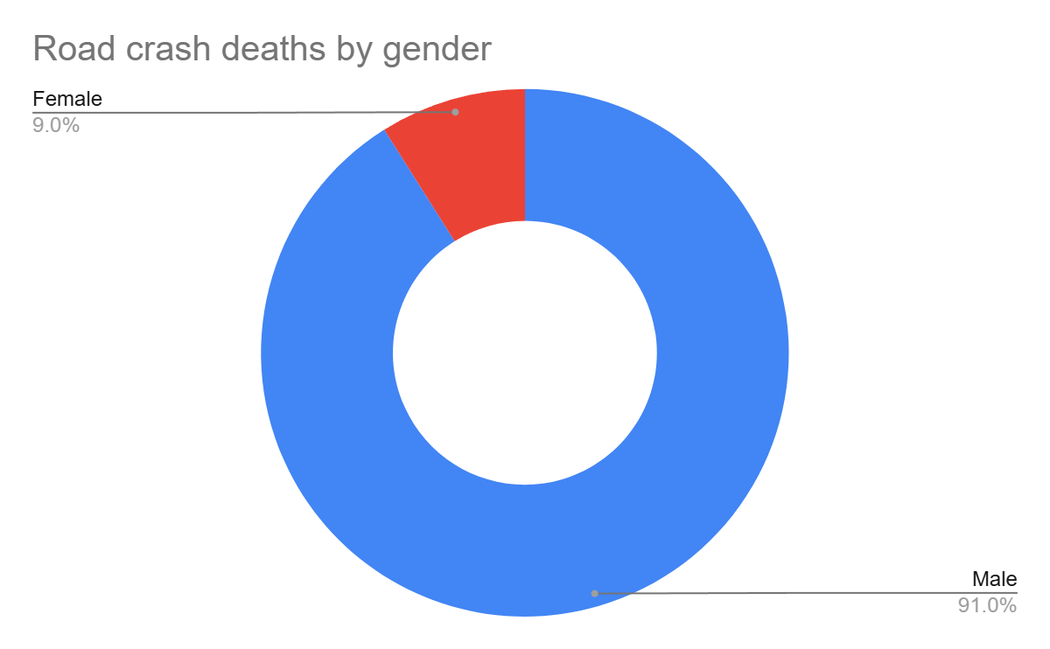

Figure 5: Road cash deaths by gender

### : Road crash deaths by age-groups and gender

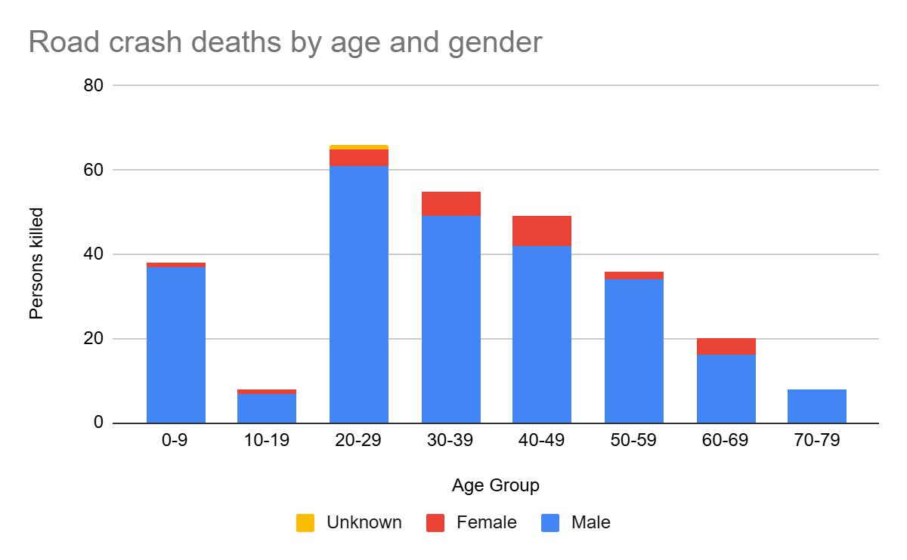

Figure 6: Road crash deaths by age groups and gender

Looking at the absolute numbers, the males had a higher number of fatalities 91% compared to females. Among the males, the fatalities were observed to be highest in the age group of 20-29 years, followed by 30-39 years.

## : Road crash deaths by road user type

### : Total Road crash deaths by road user type (2019, 2021, 2022)

Total fatalities:280

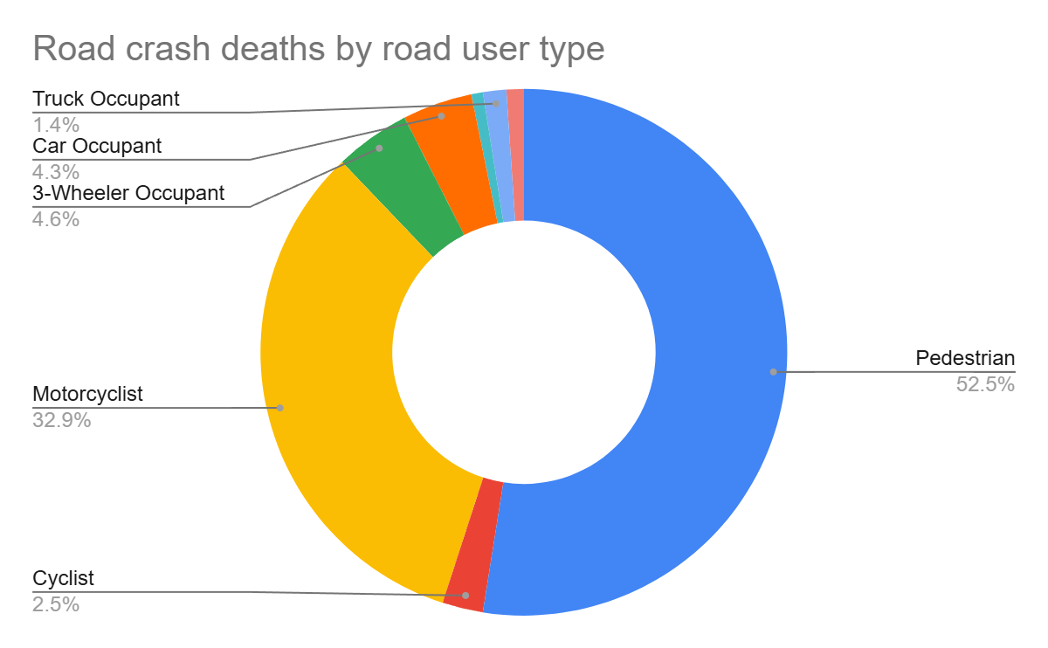

Figure 7: Road crash deaths by road user type (2019, 2021, 2022)

*Other includes cycle rickshaws, converted rickshaws and hand carts

Ninety-three percent of fatalities were among vulnerable road users (i.e., pedestrians, motorcyclists, cyclists, and auto rickshaw occupants). Among this, fifty three percent of road crash deaths in the Shahdara district were among pedestrians, followed by motorcyclists (33%).

### : Timewise Road crash deaths by Road user type

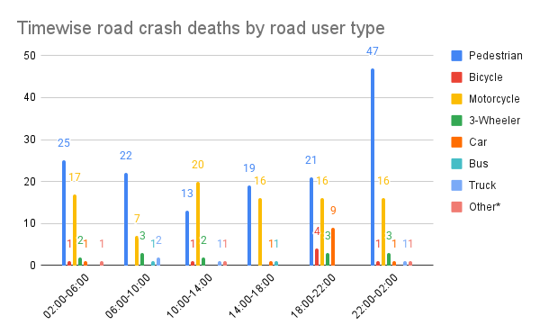

Figure 8: Timewise Road crash deaths by road user types

*Other includes cycle rickshaws, converted rickshaws and hand carts

### : Who-hit-whom matrix

|  |  |  |  |  |  |  |  |  |  |
| --- | --- | --- | --- | --- | --- | --- | --- | --- | --- |
| **Victim Road User** | **Impacting Vehicle** | | | | | | | | |
| **Motorcycle** | **3-Wheeler** | **Car** | **Bus** | **Truck/ Tractor** | **Single Vehicle Crash** | **Other** | **Unknown** | **Total** |
| **Pedestrian** | 12 | 5 | 15 | 7 | 31 | 0 | 0 | 77 | 147 |
| **Cyclist** | 0 | 0 | 1 | 1 | 2 | 0 | 1 | 2 | 7 |
| **Motorcyclist** | 3 | 2 | 10 | 9 | 12 | 6 | 8 | 42 | 92 |
| **3-Wheeler Occupant** | 0 | 0 | 0 | 1 | 3 | 1 | 4 | 4 | 13 |
| **Car Occupant** | 1 | 0 | 10 | 0 | 1 | 0 | 0 | 0 | 12 |
| **Bus Occupant** | 0 | 0 | 0 | 0 | 0 | 0 | 2 | 0 | 2 |
| **Truck Occupant** | 1 | 0 | 0 | 0 | 0 | 0 | 1 | 2 | 4 |
| **Other** | 0 | 0 | 0 | 0 | 1 | 0 | 0 | 2 | 3 |
| **Total** | 17 | 7 | 36 | 18 | 50 | 7 | 16 | 129 | 280 |

Table 2: Who-hit-whom matrix

Note: Other includes cycle rickshaws, converted rickshaws and hand carts

Among all fatal road crashes where the impacting vehicle was known, pedestrians and motorcyclists were found to be the most vulnerable category of road users. They were often hit by trucks and tractors. Hit-and-run crashes dominate both the categories of cases where the impacting vehicle was not known for 77 cases in case of pedestrians and 42 in case of motorcyclists.

## : Hit-and-runs in fatal road crashes

### : Percentage of hit-and-run and non-hit-and-run cases

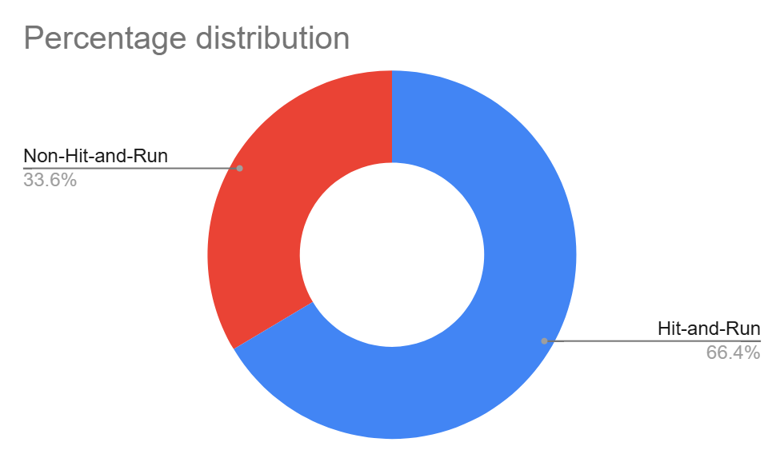

Figure 9: Percentage of hit-and-run and non-hit-and-run cases

Overall, two out of three crashes are hit-and-run cases. The high rate of hit-and-run cases is indicative of non-reporting of accused vehicles as well as non-reporting of crashes by the public.

### : Hit-and-run Road user types

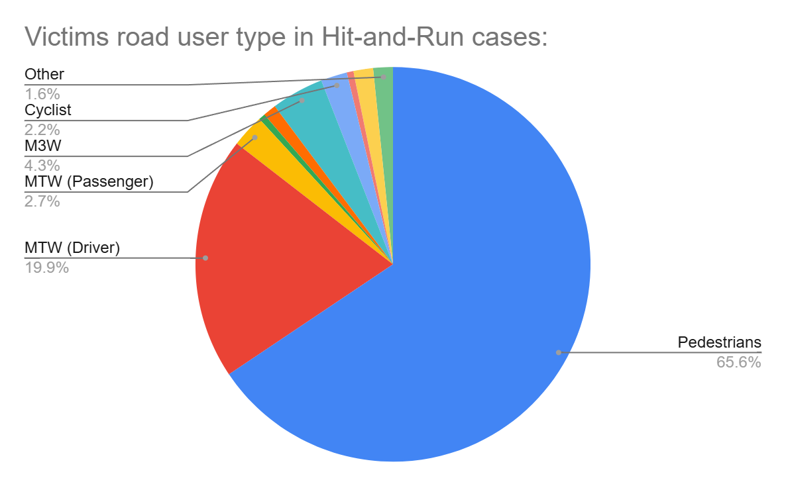

Figure 10: Hit-and-run Road user types

## : Road Crash Heatmaps

### : Heatmap of all road crash deaths

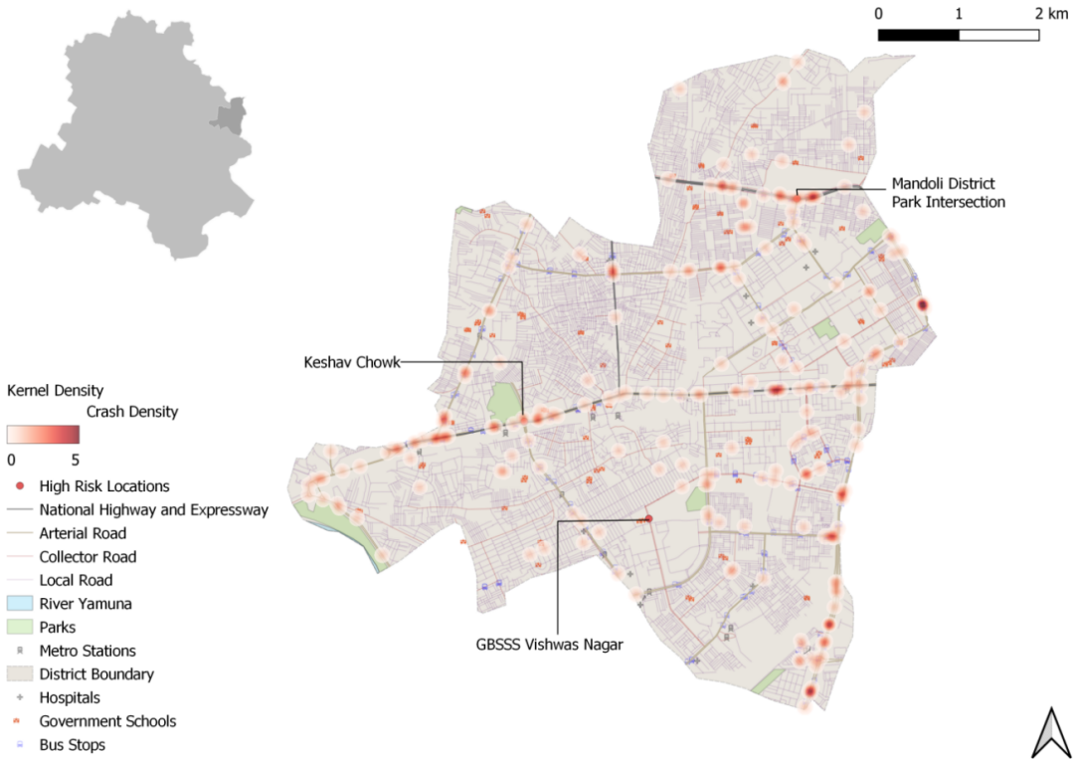

Figure 11: Heatmap of all road crash deaths in Shahdara district

### : Heatmap of all pedestrian deaths

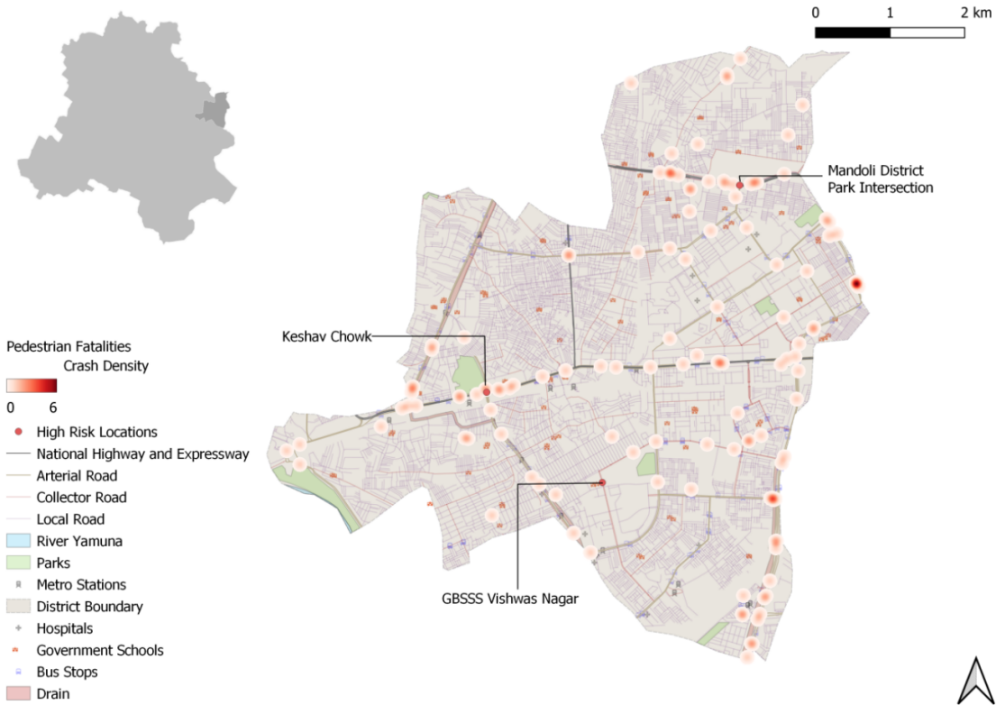

Figure 12: Heatmap of all pedestrian deaths due to road crashes in Shahdara District

### : Heatmap of all motorcycle (rider + pillion) related deaths

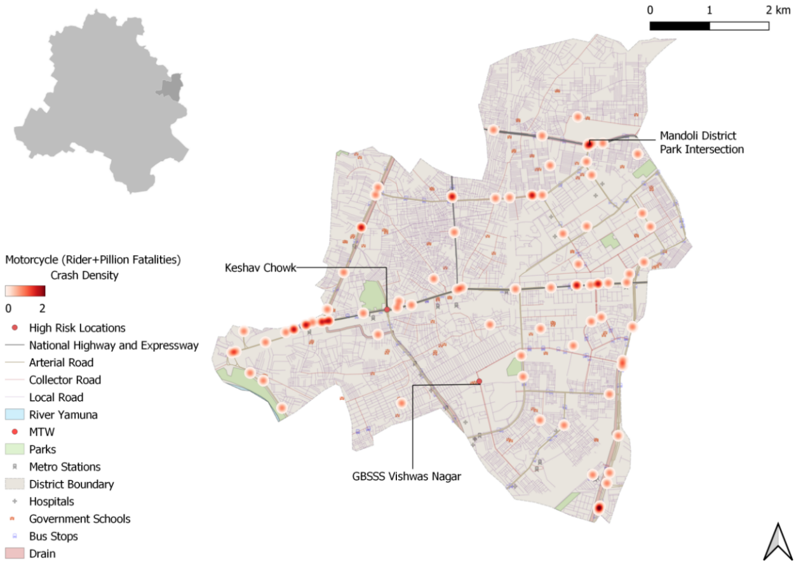

Figure 13: Heatmap of all motorcycle related deaths due to road crashes in Shahdara District

## : High Risk Locations

### : List of high-risk locations

The following is a list of high-risk locations in the Shahdara district which includes the number of fatal crashes, hit-and-run crashes, and deaths occurred during these crashes in years 2019, 2021 and 2022.

|  |  |  |  |
| --- | --- | --- | --- |
| **High Risk Location** | **Total fatal crashes** | **Total hit and run fatal crashes** | **Total persons killed** |
| Keshav Chowk | 14 | 11 | 14 |
| Mandoli District Park Intersection | 15 | 10 | 15 |
| GBSSS Vishwas Nagar | 0 | 0 | 0 |

Table 3: List of high-risk locations

### : Map of all high-risk locations

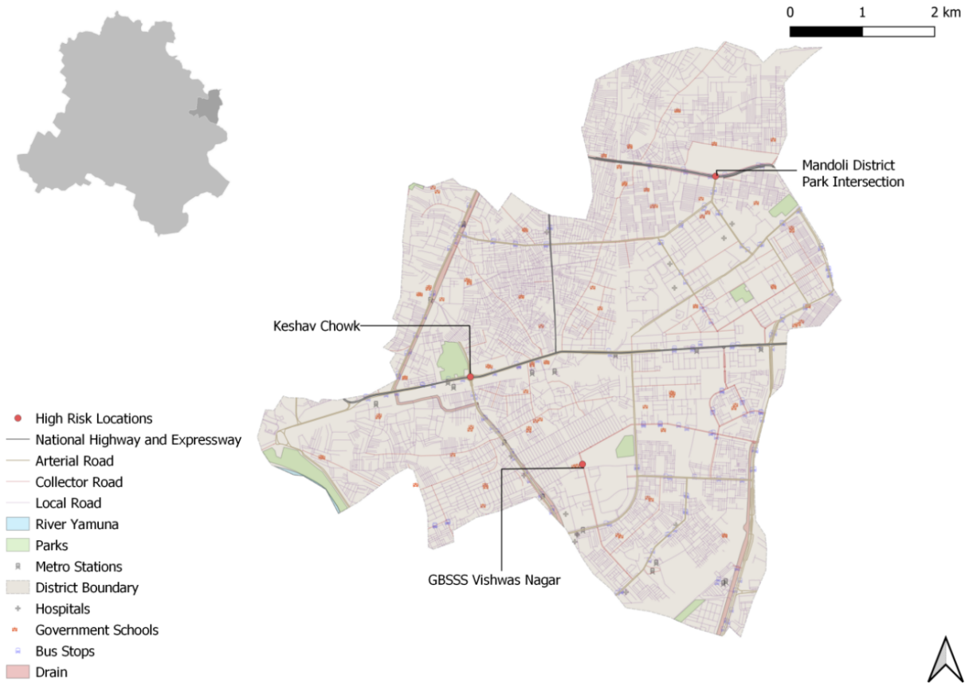

Figure 14: Map of all high-risk locations intervened in Shahdara District

### : High risk corridors

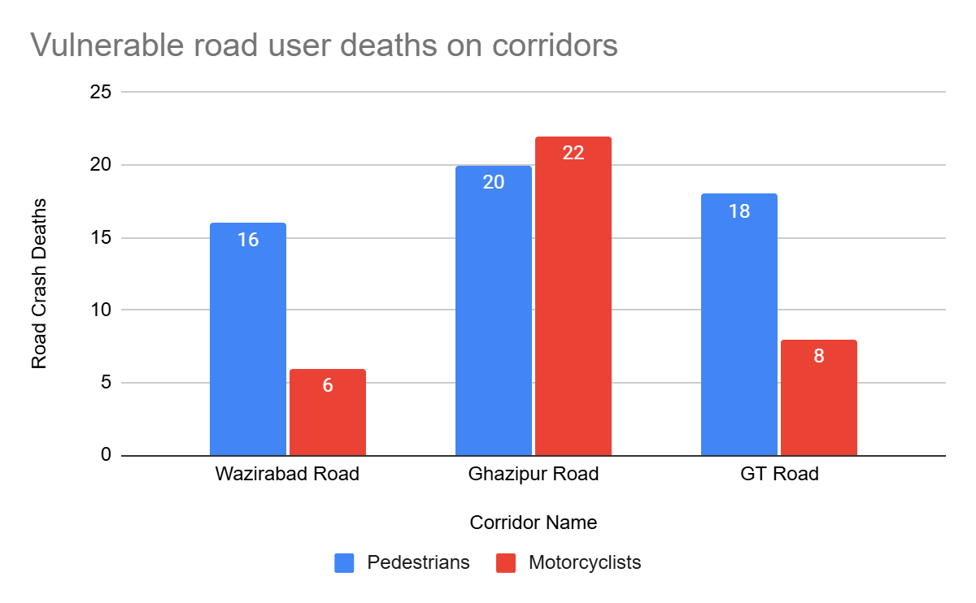

Figure 15: Vulnerable Road users on corridors

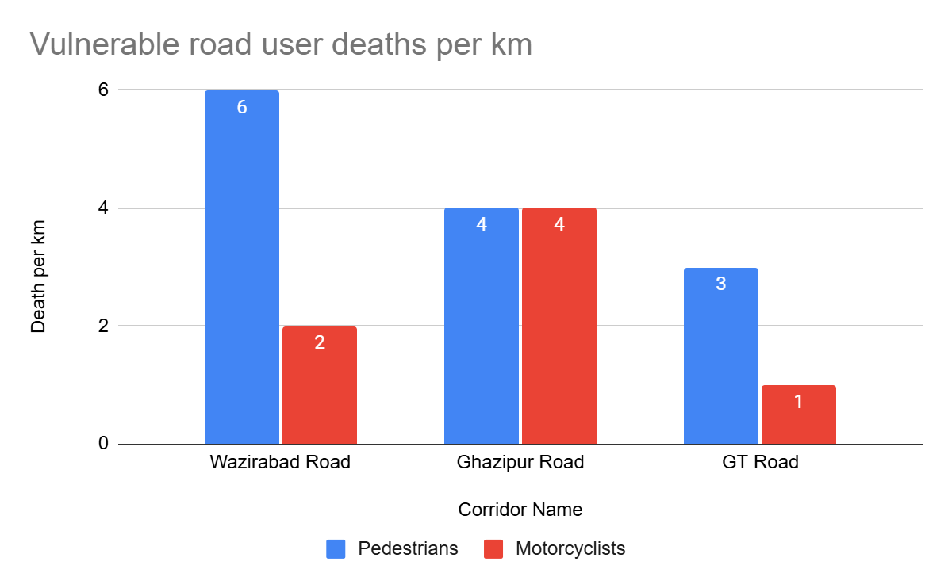

Figure 16: Vulnerable Road users’ death per km

# **: Data to Action**

## : metro store seelampur intersection

### : General Description of the site

Metro Store Seelampur Intersection (Latitude:28°40'16.55"N, Longitude: 77°16'8.57"E). It is a 3 Arm Junction which is signalised. The intersecting road names are Grand Trunk Road (Arterial Road) and Jafarabad Main Road (Collector Road).

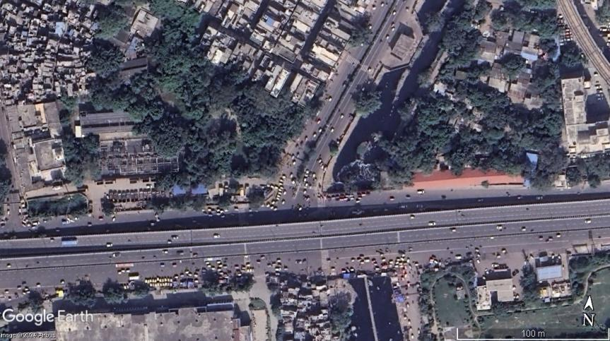

Figure 17: Metro Store Seelampur Intersection satellite image

### : Existing Land Use

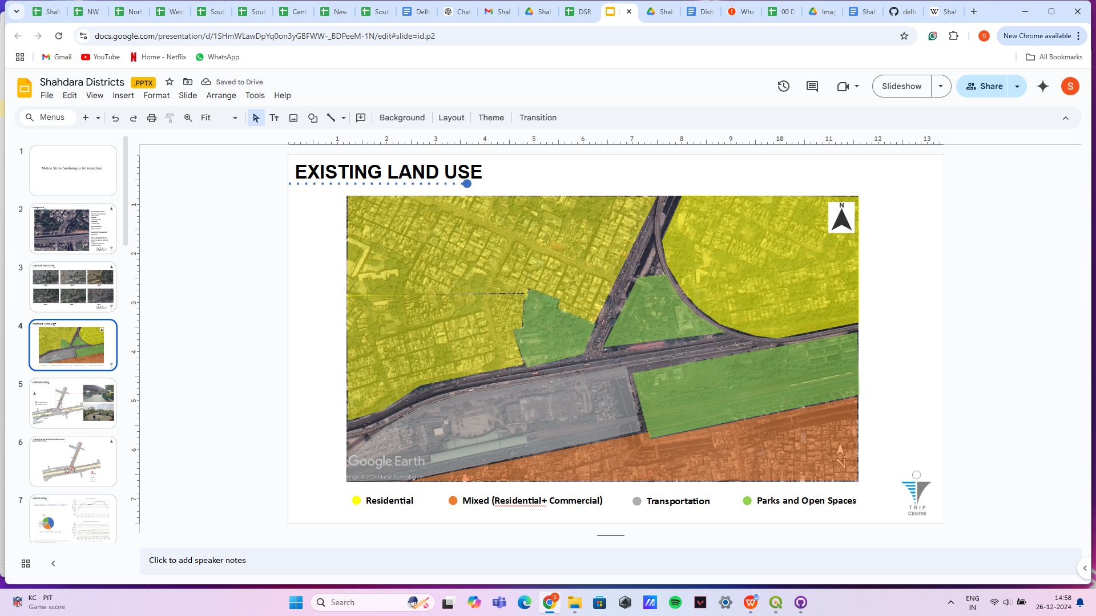

Figure 18: Existing land use around Metro Store Seelampur Intersection

### : Conflict Points

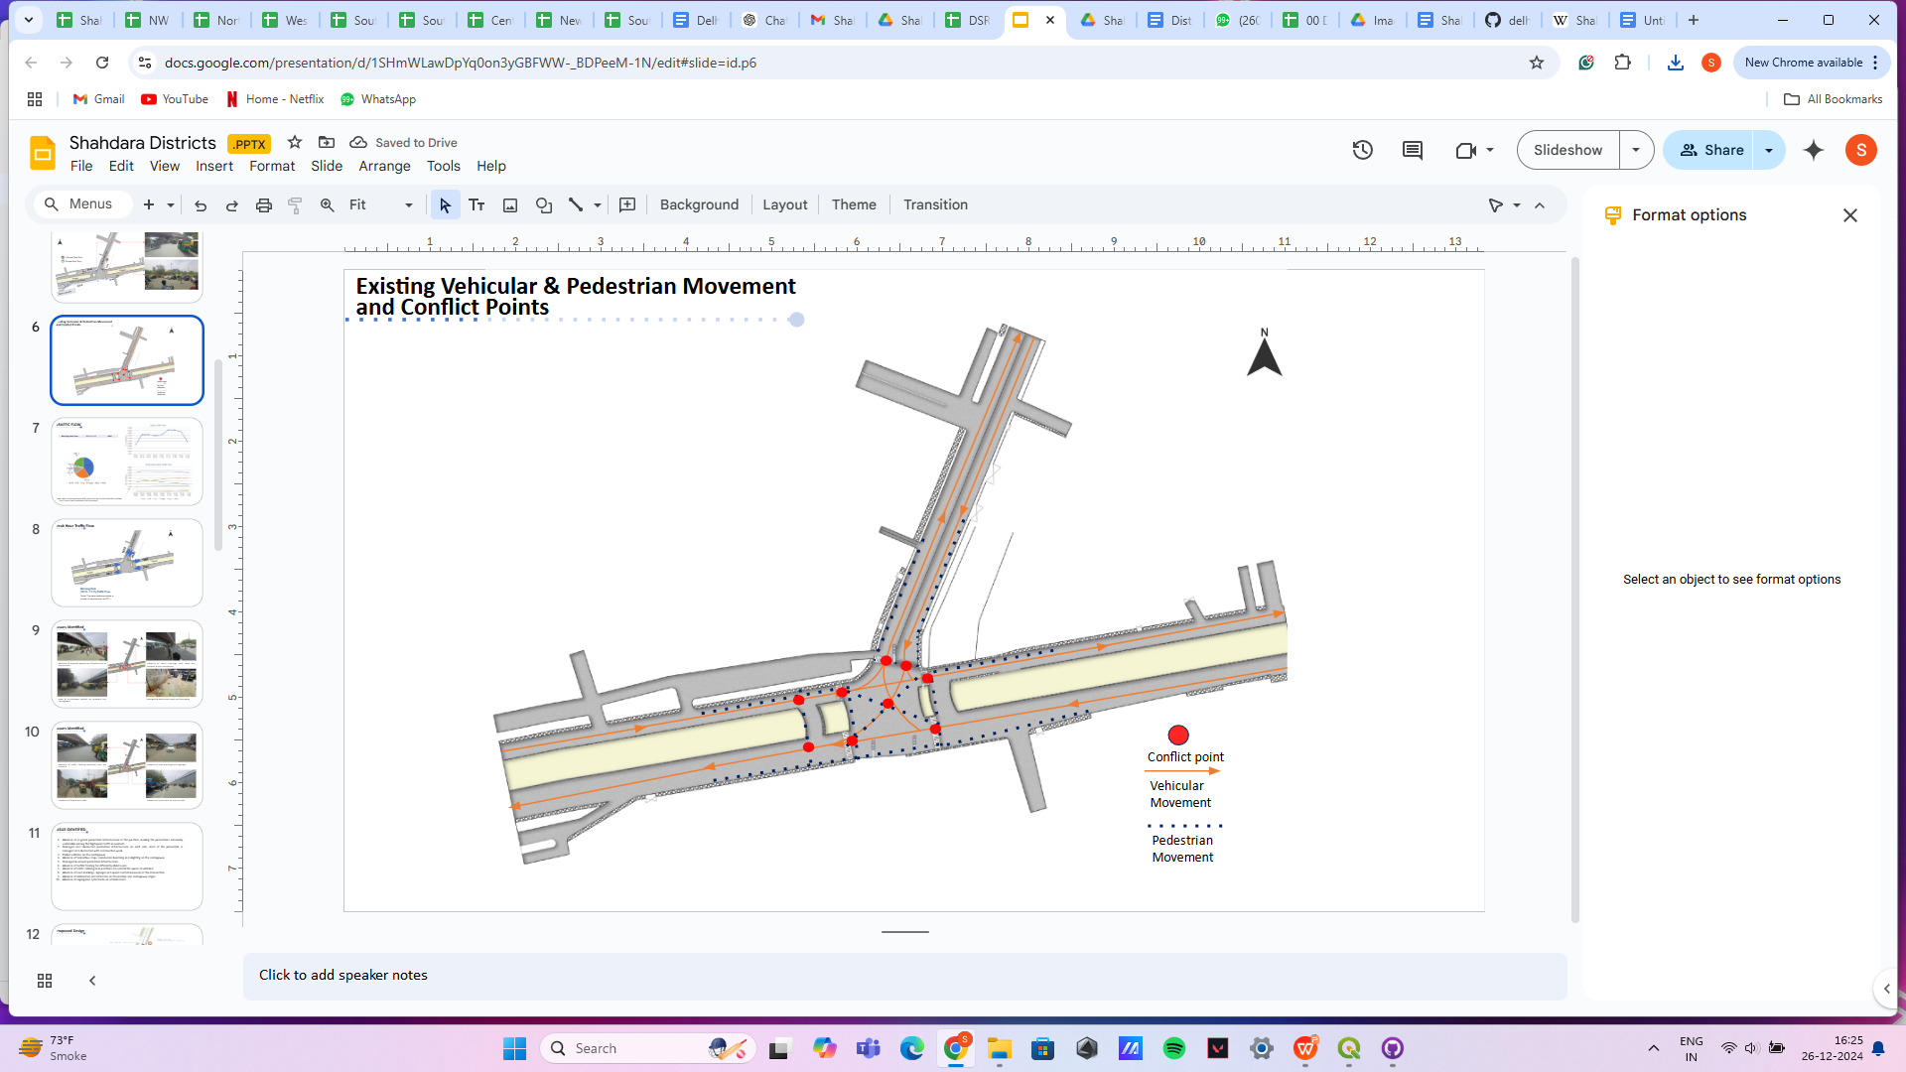

Figure 19: Conflict points at Metro Store Seelampur Intersection

### : Existing Scenario

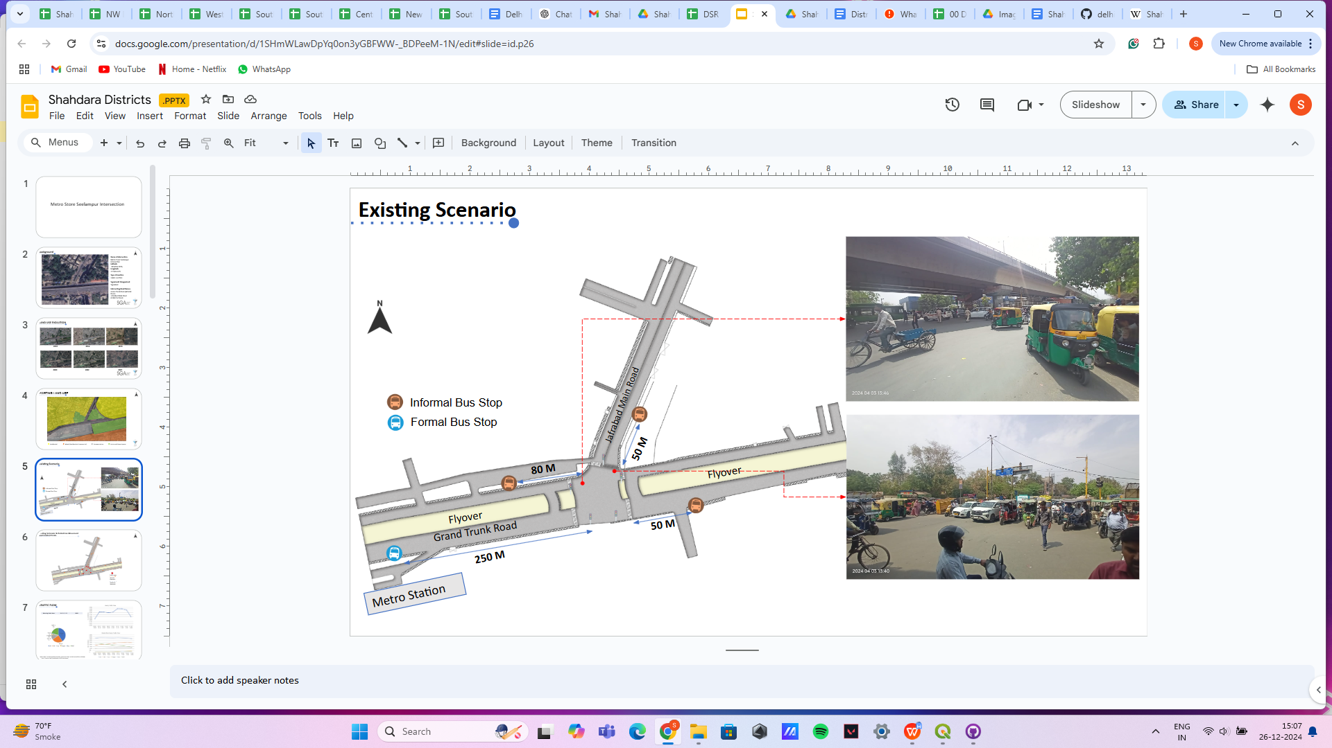

Figure 20: Existing scenario of Metro Store Seelampur Intersection

### : Issues Identified

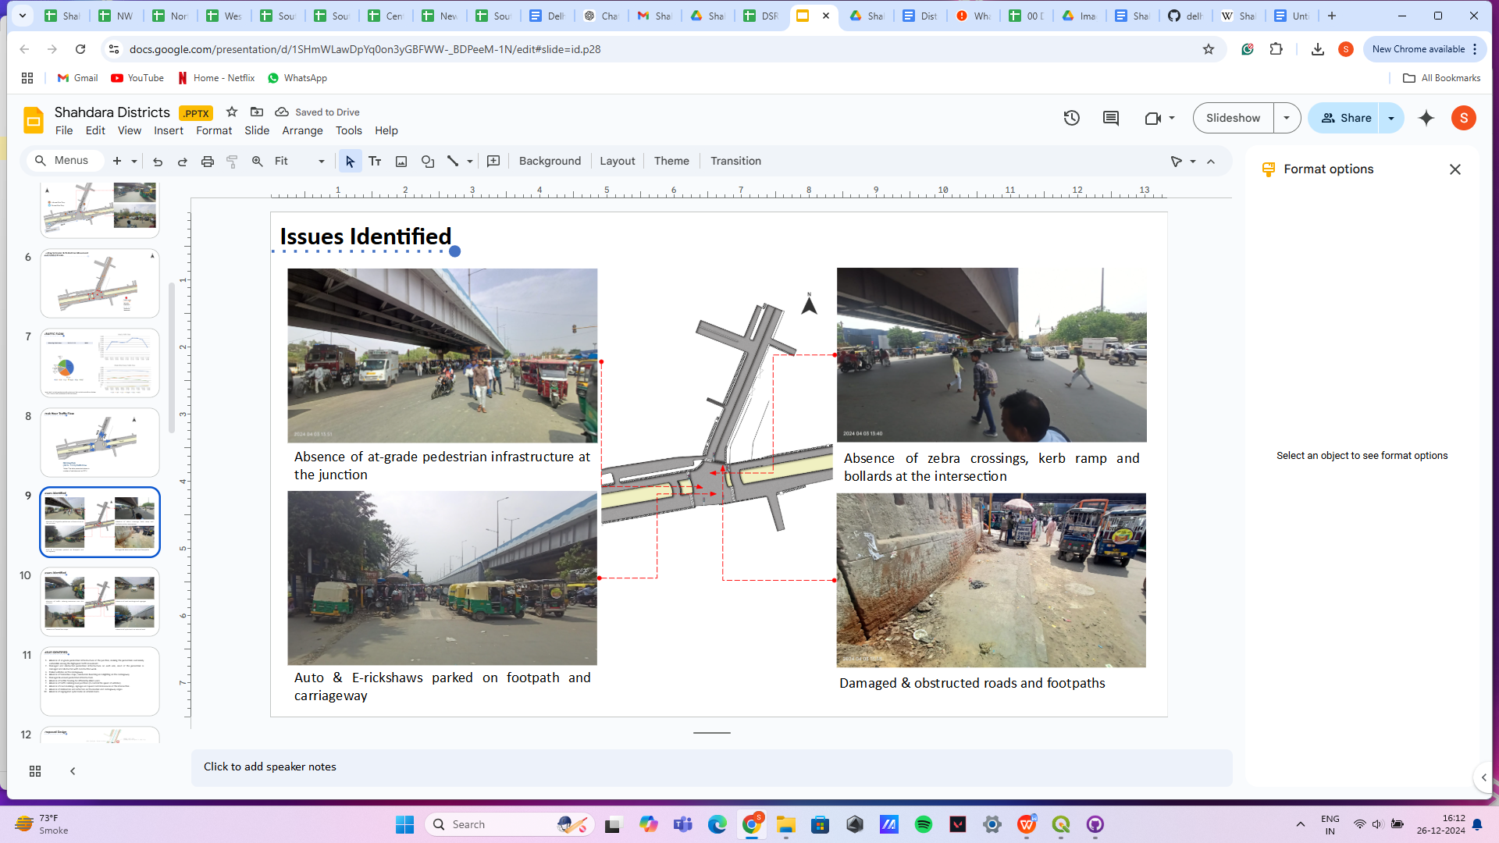

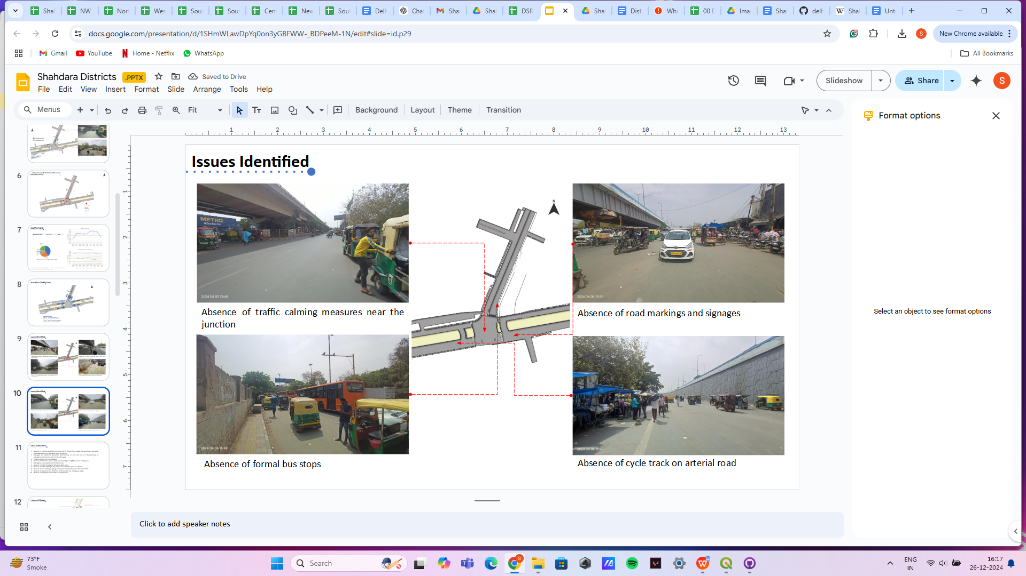

Figure 21: Issues identifies at Metro Store Seelampur Intersection

1. Absence of at-grade pedestrian infrastructure at the junction, making the pedestrians extremely vulnerable among the highspeed traffic movement.
2. Damaged and obstructed pedestrian infrastructure on each arm, most of the pedestrian is damaged and obstructed with construction work.
3. Parked vehicles on the carriageway
4. Absence of formal bus stops, commuters boarding and alighting on the carriageway
5. Damaged & uneven pedestrian infrastructure.
6. Absence of tactile flooring for differently abled users.
7. Absence of traffic calming near junctions (to control the speed of vehicles).
8. Absence of road markings, signages and speed control measures at the intersection.
9. Absence of delineators and reflectors on the median and carriageway edges.
10. Absence of segregated cycle tracks on arterial roads.

### : Proposed Design

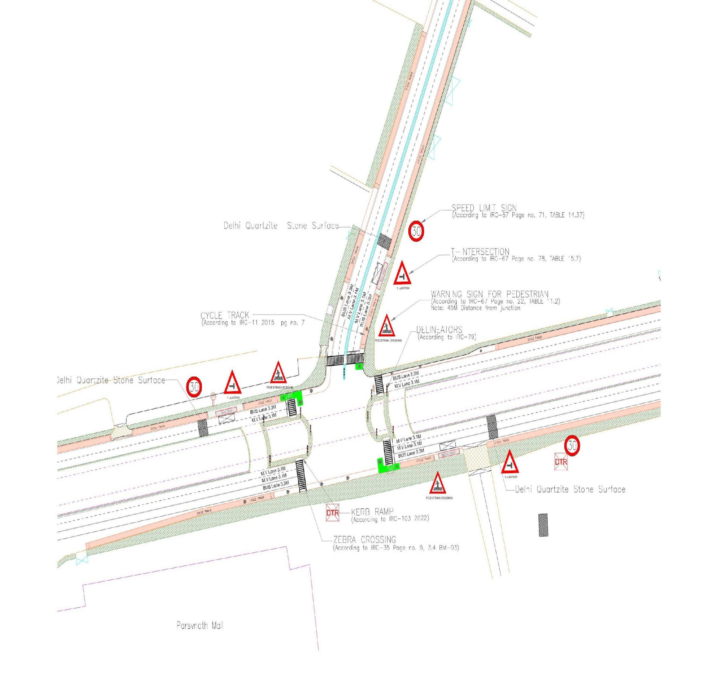

Figure 22: Proposed design for Metro Store Seelampur Intersection

1. The junction is redesigned for the speed of 30 km/hr to ensure the safety
2. Proposed new bus stop near the junction to reduce the pedestrian crossing movement
3. Dedicated 2.5m wide cycle track to separate the motor traffic and the cyclists (as per IRC: 11-2015)
4. Installation of signages - Speed Limit, stop sign, pedestrian crossing and other necessary Signages on all approaching roads
5. Provision of Delhi Quartzite stone surface to slow down the approaching traffic
6. Demarcation of Road Markings (properly painted as per IRC 35)
7. Provision of kerb ramps for the accessibility of differently abled users (as per IRC:103-2022)

### 

### : Summary budget estimates

| **S. No.** | **Component** | **Details** | **Notes** | **Rate (per sq.m.)** | **Cost (INR)** | **Cost (INR, crores)** |
| --- | --- | --- | --- | --- | --- | --- |
| **A** | **CIVIL WORK** |  |  |  |  |  |
| A.1 | Footpath (Primary, Secondary including other Flooring area) | 2m to 3m wide segregated footpath with tactile pavers | Providing and Laying of footpath 2m to 3m wide, including earthwork and base layer - PCC, GSB and finsihing material. | 2637 | 88,61,190 | 0.886 |
| A.2 | Raised Crossing | Raised crssing with 80mm thick pavers and DQ stone surface | Providing and laying Raised crosseing with 80 mm thk pavers blocks, and DQ stone including Earth work and Base layers- PCC (M15), RCC (M30 Design mix) & GSB etc. | #DIV/0! | - | 0.000 |
| A.3 | Cycle Infrastructure | 2.5m wide segregated cycle track | Providing and laying cycle track (2.5mt wide segregated) inculding Earth work and Base layers- PCC (M15), RCC (M40 Design mix) & GSB etc. also thermoplastic paint for marking and cycle symbol and spring post etc | 3928 | 47,61,296 | 0.476 |
| A.4 | CC Items (Kerbs, Pipe, etc) | Kerb stones, Bollards, Kerb Channels etc. | Providing and fixing Kerbs, Bollards , and Kerb Channel etc. in CC. |  | 12,95,831 | 0.130 |
| A.5 | Signages | Mandatory, Cautoniory and Informatory Sign Boards of different sizes | Providing and fixing Signage Mandatory, Cautonory and informatory sign board inculding all the fixing and labours etc. |  | 72,548 | 0.007 |
| A.6 | Marking | Thermoplastic Paint Marking (Edge lines, Centre Line, Lane Marking, Hazard Marking, Chevron, Zebra Crossing, Bar Marking, etc) | Providing and applying road marking strips (retro- reflective) of specified shade/ colour using hot thermoplastic material for road marking . | 748 | 3,18,563 | 0.032 |
| A.7 | Special Zones | Provision of Sitting Bollards, CC Benches, GRC Jali, Pergola, Dustbin etc. | Miscellaneous items- Provision of Sitting Bollards, CC Benches, GRC Jali, Pargola, Dustbin etc. complete items- including foundation and fixing etc. |  | 1,00,880 | 0.010 |
| A.8 | Brick Work |  | Brick work with common burnt clay F.P.S. (non modular) bricks of class designation 7.5 in foundation and plinth in:Cement mortar 1:4 (1 cement : 4 coarse sand) | 7370.65/CUM | 2,94,826 | 0.029 |
| A.9 | Steel Reinforncement for RCC work |  | Steel reinforcement (in per kg) for R.C.C. work including straightening, cutting, bending, placing in position and binding all complete upto plinth level.Thermo-Mechanically Treated bars of grade Fe-500D or more | 107.85/kg | 43,140 | 0.004 |
| A.10 | Pavement Surface Dressing | Pavement of Bitumen layer on existing road surface | Surface dressing on old surface with hot bitumen of grade VG - 10 | 175.10 / sq.m | 15,53,662 | 0.155 |
| A.11 | Safety Management Equipment (as per design requirement) | Provision of Delieator Post, Spring Post, Cat eye/studs etc. | Miscellaneous items for Safety Management Equipment ( as per design requirement) -Provision of Delieator Post, Spring Post, Cat eye/studs etc.- including foundation and fixing etc. |  | 97,961 | 0.010 |
| A.12 | Bus Shelter | 10.5mX2.5m Bus Sheltor (Stainless Steel Strcuture) |  |  | 54,00,000 | 0.540 |
|  | **SUB TOTAL CIVIL WORK (A)** |  |  |  | **2,27,99,898** | 2.280 |
| **B** | Drainage, Irrigation & Plumbing | (Drainage items based on design proposal) | Drainage, Irrigation & Plumbing work @ 20% of the cost of Civil work | 20% | **45,59,980** | 0.456 |
| **C** | Electrical Work | (Light poles, junction box, other electrical works proposed based on design proposal) | Electrical work @25% of the cost of Civil work | 25% | **56,99,974** | 0.570 |
| **D** | Horticulture Work | (Landscape items based on design proposal) | Horticulture work @ 15% of the cost of Civil work | 15% | **34,19,985** | 0.342 |
| **E** | Dismantling / Demolition | -- | Dismantling work @ 15% of the cost of Civil work | 15% | **34,19,985** | 0.342 |
| **F** | Work Zone Safety & Management | -- | Work zone Management @ 5% of the cost of Civil work | 5% | **11,39,995** | 0.114 |
| **PART 1** | **SUB TOTAL PART 1 (A+B+C+D+E+F)** |  |  |  | **4,10,39,816** | 4.104 |
| **G** | Design Services & Support | -- | Design Consultancy (Preparation of Drawings, BOQ support, Work Zone plan, Site Supervision, Community Engagement & Liason, Change Management @ 2% - 8% of the cost of Civil work. | **2%** | **8,20,796** | 0.082 |
| **H** | Survey Cost | -- | Survey Cost (Total Station Survey, underground services, tree demarcation, girths , level differences, steps etc @ ( 80,000 per junction - 250m on each arm ) | 80000 | **80,000** | 0.008 |
| **PART 2** | **SUB TOTAL PART 2 ( PART 1 + G +H)** |  |  |  | **4,19,40,612** | 4.194 |
| **J** | Contigencies '2.5% | -- | Contingencies (@2.5% ) |  | **10,48,515** | 0.105 |
| **I** | GST('@18%) | -- | GST @18% |  | **77,38,043** | 0.774 |
| **FINAL** | **GRAND TOTAL (PART 2 + J + I)** |  |  |  | **5,07,27,171** | 5.073 |

**Notes:**

1. This is a preliminary estimate. Final costing to be evaluated & approved by the road owning agency.
2. DSR 2023 has been followed for all rates. Market Rate and Costing from part PWD projects has been included for certain items.
3. Cost of Drainage, Irrigation, Plumbing has been calculated at 20% of the civil work cost.
4. Cost of Electrical Work can be calculated at 20% - 25 % of the civil work cost.
5. Cost of Horticulture has been calculated at 15% of the civil work cost.
6. Cost of Dismantling has been calculated at 15% of the civil work cost.
7. Cost of Work Zone Management has been calculated at 5% of the civil work cost
8. Cost for Design Support can range from 2% - 8%, can vary from site to site. This should include Technical Assistance on drawings, 3D supports, Site Supervision, Change management.
9. Bus Shelter has been calculated at 18 L per shelter; can be changed as per design specific cost.
10. In case of new items specific to design, please add relevant rows in detail budget estimation and include the same in the budget summary under relevant head.

## : DURGAPURI CHOWK

### : General description of the site

Durgapuri Chowk Intersection (Latitude: 28°41'21.65"N, Longitude: 77°17'31.06"E). It is a 4-arm signalised junction. This intersection is intersecting Main 100 feet Road (Collector Road) and Saharanpur-Delhi Road(Collector Road)

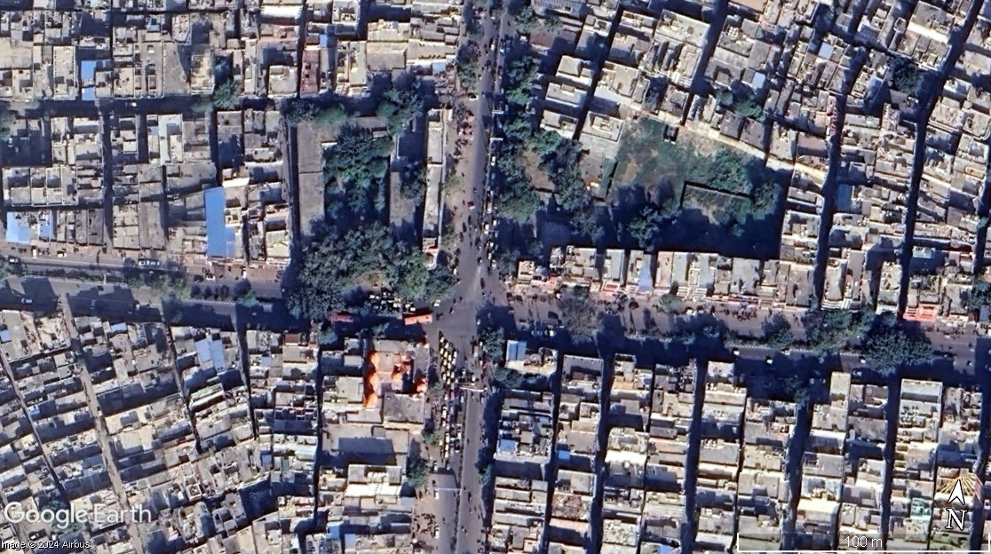

Figure 23: Durgapuri Chowk Intersection satellite image

### : Existing Land Use

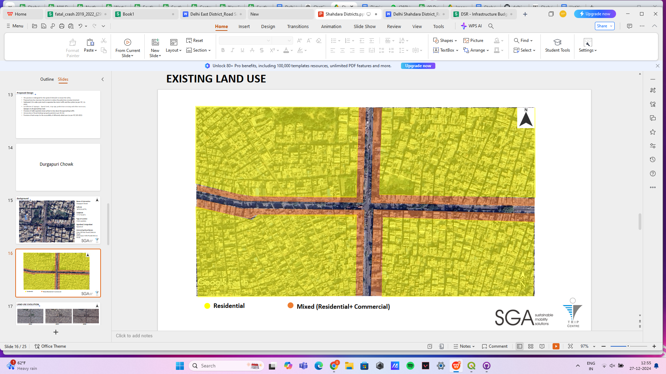

Figure 24: Existing land use near Durgapuri Chowk Intersection

### : Existing Scenario

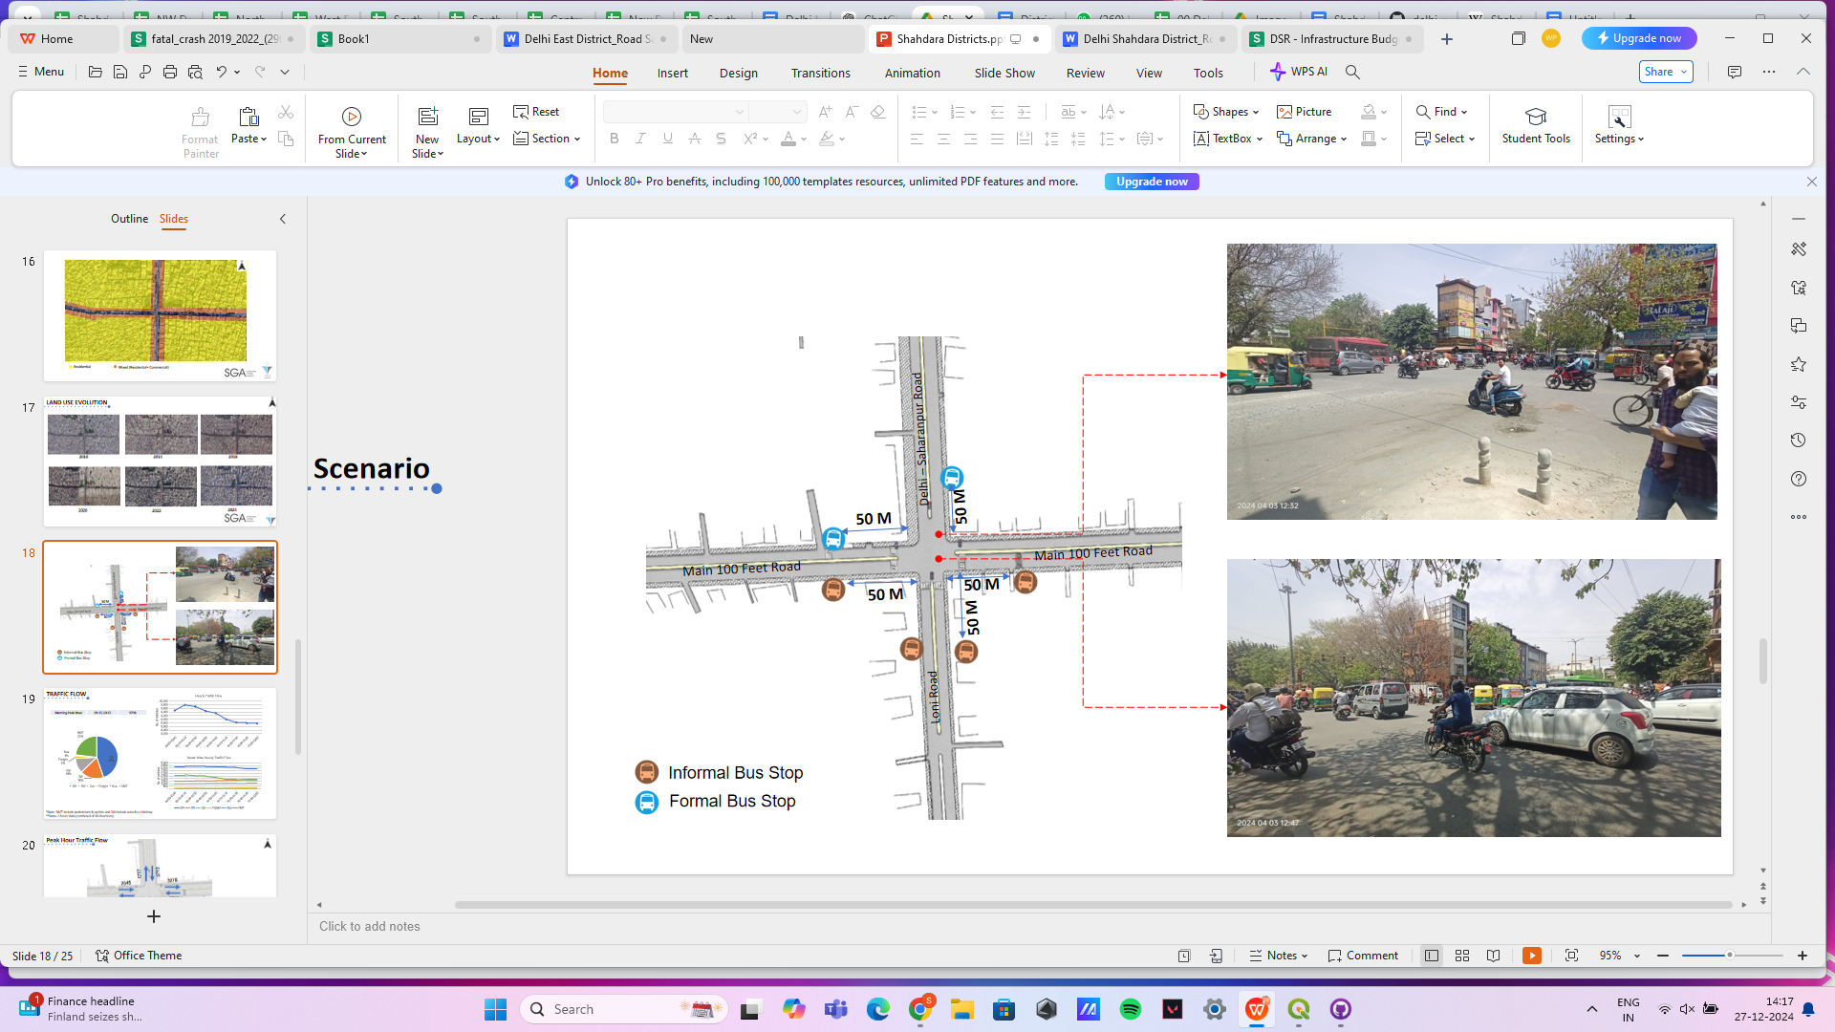

Figure 25: Existing scenario at Durgapuri Chowk Intersection

### : Issues identified

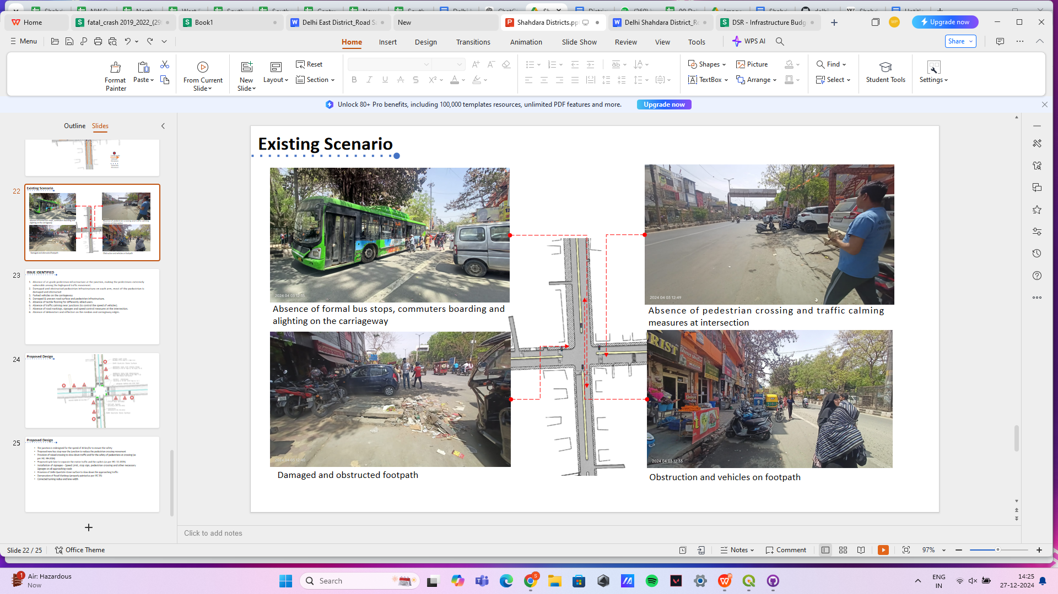

Figure 26: Issues identified at Durgapuri Chowk Intersection

1. Absence of at-grade pedestrian infrastructure at the junction, making the pedestrians extremely vulnerable among the highspeed traffic movement.
2. Damaged and obstructed pedestrian infrastructure on each arm, most of the pedestrian is damaged and obstructed
3. Parked vehicles on the carriageway
4. Damaged & uneven road surface and pedestrian infrastructure.
5. Absence of tactile flooring for differently abled users.
6. Absence of traffic calming near junctions (to control the speed of vehicles).
7. Absence of road markings, signages and speed control measures at the intersection.
8. Absence of delineators and reflectors on the median and carriageway edges.

### : Proposed Design

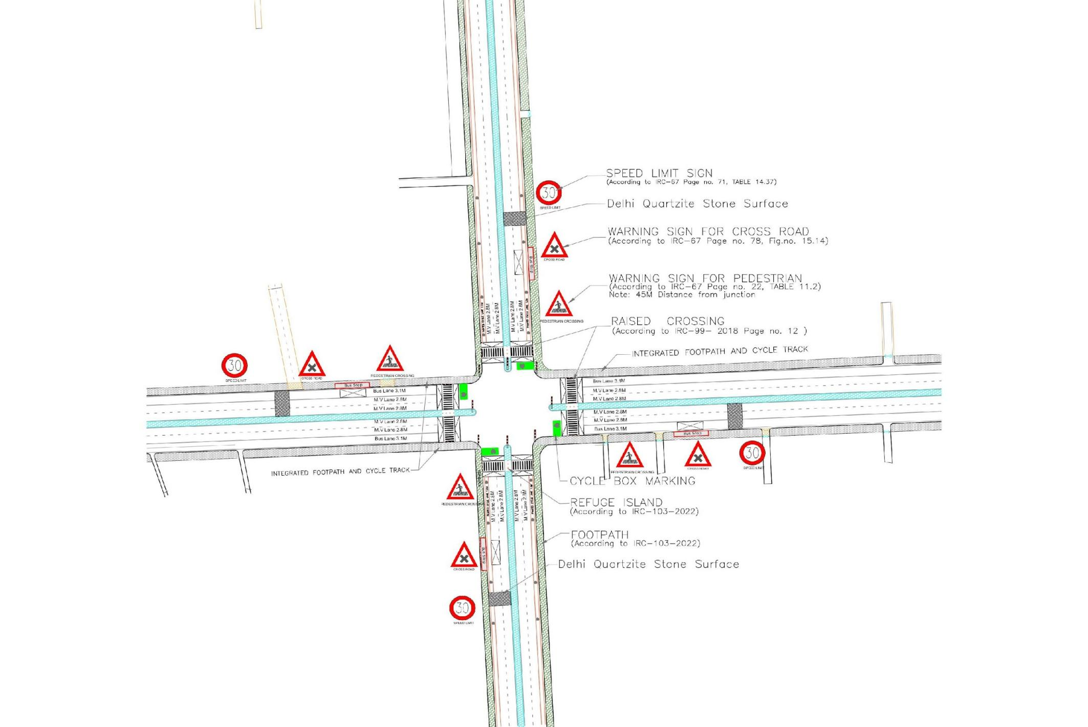

Figure 27: Proposed design for Durgapuri Chowk Intersection

1. The junction is redesigned for the speed of 30 km/hr to ensure the safety
2. Proposed new bus stop near the junction to reduce the pedestrian crossing movement
3. Provision of raised crossing to slow down traffic and for the safety of pedestrians at crossing (as per IRC: 99-2018)
4. Proposed cycle lane to separate the motor traffic and the cyclists (as per IRC: 11-2015)
5. Installation of signages - Speed Limit, stop sign, pedestrian crossing and other necessary Signages on all approaching roads
6. Provision of Delhi Quartzite stone surface to slow down the approaching traffic
7. Demarcation of Road Markings (properly painted as per IRC 35)
8. Corrected turning radius and lane width

### 

### : Summary budget estimates

| **S.No** | **Component** | **Details** | **Notes** | **Rate (per sq.m)** | **Cost (INR)** | **Cost (INR, crores)** |
| --- | --- | --- | --- | --- | --- | --- |
| **A** | **CIVIL WORK** |  |  |  |  |  |
| A.1 | Footpath (Primary, Secondary including other Flooring area) | 2m to 3m wide segregated footpath with tactile pavers | Providing and Laying of footpath 2m to 3m wide, including earthwork and base layer - PCC, GSB and finsihing material. | 2690 | 78,50,998 | 0.785 |
| A.2 | Raised Crossing | Raised crssing with 80mm thick pavers and DQ stone surface | Providing and laying Raised crosseing with 80 mm thk pavers blocks, and DQ stone including Earth work and Base layers- PCC (M15), RCC (M30 Design mix) & GSB etc. | - | 20,26,509 | 0.203 |
| A.3 | Cycle Infrastructure | 2.5m wide segregated cycle track | Providing and laying cycle track (2.5mt wide segregated) inculding Earth work and Base layers- PCC (M15), RCC (M40 Design mix) & GSB etc. also thermoplastic paint for marking and cycle symbol and spring post etc | #DIV/0! | 3,09,155 | 0.031 |
| A.4 | CC Items (Kerbs, Pipe, etc) | Kerb stones, Bollards, Kerb Channels etc. | Providing and fixing Kerbs, Bollards , and Kerb Channel etc. in CC. |  | 7,84,196 | 0.078 |
| A.5 | Signages | Mandatory, Cautoniory and Informatory Sign Boards of different sizes | Providing and fixing Signage Mandatory, Cautonory and informatory sign board inculding all the fixing and labours etc. |  | 96,731 | 0.010 |
| A.6 | Marking | Thermoplastic Paint Marking (Edge lines, Centre Line, Lane Marking, Hazard Marking, Chevron, Zebra Crossing, Bar Marking, etc) | Providing and applying road marking strips (retro- reflective) of specified shade/ colour using hot thermoplastic material for road marking . | 748 | 3,64,926 | 0.036 |
| A.7 | Special Zones | Provision of Sitting Bollards, CC Benches, GRC Jali, Pergola, Dustbin etc. | Miscellaneous items- Provision of Sitting Bollards, CC Benches, GRC Jali, Pargola, Dustbin etc. complete items- including foundation and fixing etc. |  | 1,00,880 | 0.010 |
| A.8 | Brick Work |  | Brick work with common burnt clay F.P.S. (non modular) bricks of class designation 7.5 in foundation and plinth in:Cement mortar 1:4 (1 cement : 4 coarse sand) | 7370.65/CUM | 1,47,413 | 0.015 |
| A.9 | Steel Reinforncement for RCC work |  | Steel reinforcement (in per kg) for R.C.C. work including straightening, cutting, bending, placing in position and binding all complete upto plinth level.Thermo-Mechanically Treated bars of grade Fe-500D or more | 107.85/kg | 43,140 | 0.004 |
| A.10 | Pavement Surface Dressing | Pavement of Bitumen layer on existing road surface | Surface dressing on old surface with hot bitumen of grade VG - 10 | 175.10 / sq.m | 15,75,900 | 0.158 |
| A.11 | Safety Management Equipment (as per design requirement) | Provision of Delieator Post, Spring Post, Cat eye/studs etc. | Miscellaneous items for Safety Management Equipment ( as per design requirement) -Provision of Delieator Post, Spring Post, Cat eye/studs etc.- including foundation and fixing etc. |  | 51,693 | 0.005 |
| A.12 | Bus Shelter | 10.5mX2.5m Bus Sheltor (Stainless Steel Strcuture) |  |  | 36,00,000 | 0.360 |
|  | **SUB TOTAL CIVIL WORK (A)** |  |  |  | **1,69,51,541** | 1.695 |
| **B** | Drainage, Irrigation & Plumbing | (Drainage items based on design proposal) | Drainage, Irrigation & Plumbing work @ 20% of the cost of Civil work | 20% | **33,90,308** | 0.339 |
| **C** | Electrical Work | (Light poles, junction box, other electrical works proposed based on design proposal) | Electrical work @25% of the cost of Civil work | 25% | **42,37,885** | 0.424 |
| **D** | Horticulture Work | (Landscape items based on design proposal) | Horticulture work @ 15% of the cost of Civil work | 15% | **25,42,731** | 0.254 |
| **E** | Dismantling / Demolition | -- | Dismantling work @ 15% of the cost of Civil work | 15% | **25,42,731** | 0.254 |
| **F** | Work Zone Safety & Management | -- | Work zone Management @ 5% of the cost of Civil work | 5% | **8,47,577** | 0.085 |
| **PART 1** | **SUB TOTAL PART 1 (A+B+C+D+E+F)** |  |  |  | **3,05,12,773** | 3.051 |
| **G** | Design Services & Support | -- | Design Consultancy (Preparation of Drawings, BOQ support, Work Zone plan, Site Supervision, Community Engagement & Liason, Change Management @ 2% - 8% of the cost of Civil work. | **2%** | **6,10,255** | 0.061 |
| **H** | Survey Cost | -- | Survey Cost (Total Station Survey, underground services, tree demarcation, girths , level differences, steps etc @ ( 80,000 per junction - 250m on each arm ) | 80000 | **80,000** | 0.008 |
| **PART 2** | **SUB TOTAL PART 2 ( PART 1 + G +H)** |  |  |  | **3,12,03,029** | 3.120 |
| **J** | Contigencies '2.5% | -- | Contingencies (@2.5% ) |  | **7,80,076** | 0.078 |
| **I** | GST('@18%) | -- | GST @18% |  | **57,56,959** | 0.576 |
| **FINAL** | **GRAND TOTAL (PART 2 + J + I)** |  |  |  | **3,77,40,063** | 3.774 |

**Notes:**

1. This is a preliminary estimate. Final costing to be evaluated & approved by the road owning agency.
2. DSR 2023 has been followed for all rates. Market Rate and Costing from part PWD projects has been included for certain items.
3. Cost of Drainage, Irrigation, Plumbing has been calculated at 20% of the civil work cost.
4. Cost of Electrical Work can be calculated at 20% - 25 % of the civil work cost.
5. Cost of Horticulture has been calculated at 15% of the civil work cost.
6. Cost of Dismantling has been calculated at 15% of the civil work cost.
7. Cost of Work Zone Management has been calculated at 5% of the civil work cost
8. Cost for Design Support can range from 2% - 8%, and can vary from site to site . This should include Technical Assistance on drawings, 3D supports, Site Supervision, Change management.
9. Bus Shelter has been calculated at 18 L per shelter; can be changed as per design specific cost.
10. In case of new items specific to design, please add relevant rows in detail budget estimation and include the same in the budget summary under relevant head.

## 

## : Safe School Zone: Government Boys Senior Secondary School (GBSSS), Vishwas Nagar

### : General description of the site

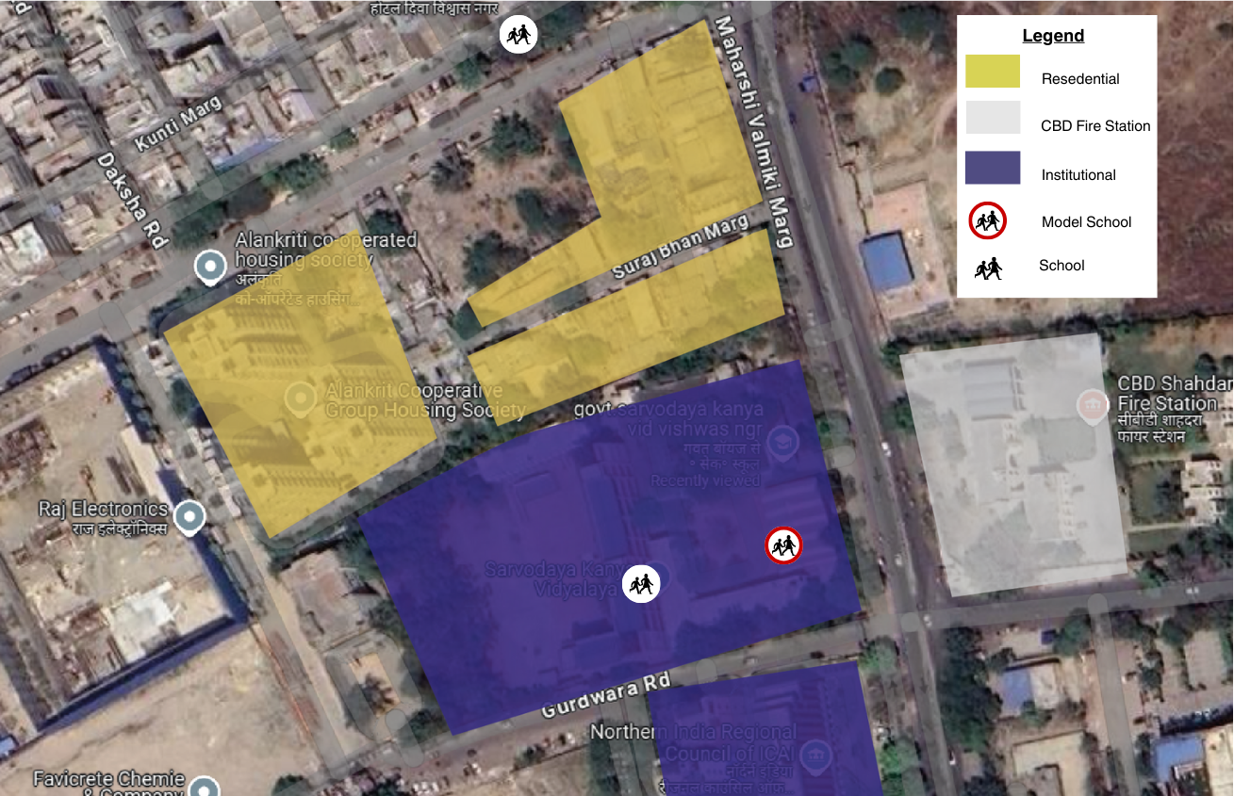

Figure 28: Land Use Map of Govt. Boys Senior Secondary School, Vishwas Nagar (AY 22-23)

|  |  |  |  |  |  |  |
| --- | --- | --- | --- | --- | --- | --- |
| **District** | **Co-ed** | **School Shift** | **Shared Campus** | **Cluster of Schools** | **Total No. of Students:** | **ROW** |
| Shahdara | No | Morning | Yes | No | 1089 | 30 m |

 Length of Intervention (all arms, in meters) : 800

Situated at Maharshi Valmiki Marg, between the Gurudwara road and Karkari road  intersection, the Govt. Boys Senior Secondary School is the pilot safe school zone site in the Shahdara district. With 3 schools in the cluster ( St. Vivekanand Modern School in the north and Govt Boys & Govt Girls ) the site was identified as a high risk location as per the Data to Action report 2022-23. The school is surrounded with a predominantly mixed land use with a CBD fire station opposite to the school. The school complex has a total of two gates. Gate no 1 opens on the Maharishi Valmiki Marg and Gate 02 opens on the Gurudwara road.  Govt. Senior Secondary School has a total enrollment of 1089 students (as per AY 22-23) from class VI to XII (age 12 to age 17). With a distribution of 43.5% students in the middle wing, and 56.5% in the senior secondary wing, the school has children from age 12 to 17 travelling to and from school.  The largest mode of transport observed in the school is walk.

### : Existing Scenario

As per a travel survey conducted in Dec ‘22, response from  147 students (13% of total school population) was mapped to understand travel patterns and socio-emotional data relevant to school journeys.

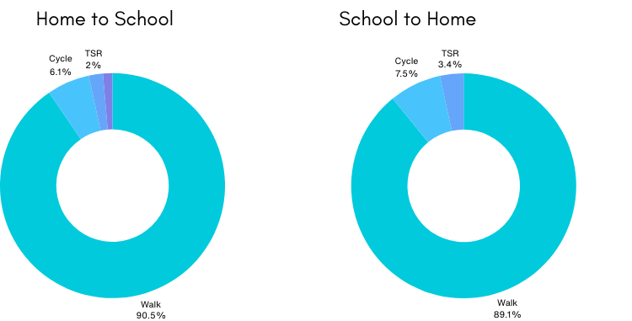

Figure 29: **School Travel Data**

*Source: HumanQind School Travel Survey 22-23*

* Walking is the most common travel mode for the students of the school, Around 90% of the students walk.
* Out of the remaining 7% of the students cycle.
* In the afternoon there are some private vehicles which drop the students to school but none in the evening.
* Amongst the modes public transport and bicycles were reported as the modes where the students felt the most unsafe; with an average 30% and 27% reporting they felt fear while travelling respectively.
* In other modes, less than 15% of the students reported feeling unsafe.

### : Issues identified

**Observations on Road Infrastructure:** The school is located on a collector road. Due to the traditional vehicle-centric planning approach, the road infrastructure does not promote pedestrian safety and creates an unsafe environment for the vulnerable road users, putting school children at risk. Conflict between students and moving vehicles have been seen during the entry and exit hours of school. This increases the probability of injuries.

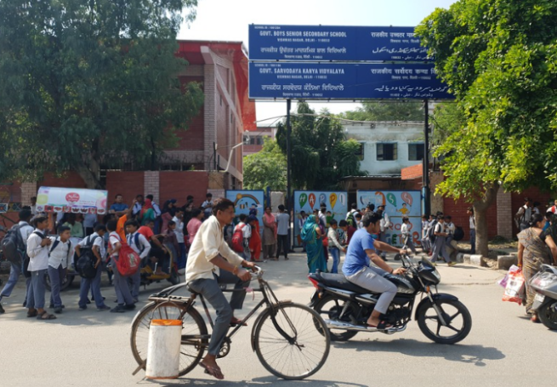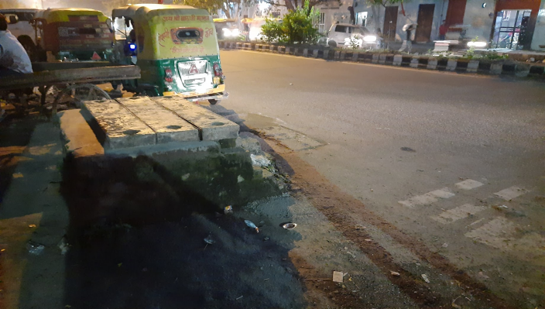

Figure 30: Site Photographs : Govt. Boys Senior Secondary School - School traffic with students walking between vehicles and walking on insufficient footpaths at Maharishi Valmiki Marg and Gurudwara Road

No slow zone, over speeding and unsafe intersections with lack of traffic calming are observed, lack of accessible and continuous footpaths, safe space for cyclist signages and marking,are also some of the visible issues. The adjoining Gurudwara Road has open drainage which leads to a highly unsafe environment for the children. Encroachments and obstacles on the existing footpath, inadequate width, inaccessible height and non-integration of green areas, waiting spaces and vendor zones. Students also have to walk in the dark with less provision of street lights. Better requirements for drainage and other utilities are observed.

**Type and quality of enforcement**

School gate directly opens on the street with high speed traffic. Unorganised parking, lack of dedicated pick up and drop off zone and poor traffic management around the school leads to an unsafe and high risk environment.

Since this is a shift school, the exit hour for the morning school affects the entry hours of the afternoon school, leading to crowding and chaos in front of the school gates, which students find difficult to navigate. Due to the conflict, students spillover onto the main carriageway exposing them to high risk of being hit by a moving vehicle.

**Road users behaviour and mobility patterns**

To understand the patterns of movements and conflicts in the school zone, activity mapping was conducted around the school. An activity map documents all users including vendors, vehicular movements & parking in a particular road environment during a certain time.

**Fear experienced during school travel:** About 41% of the students feel unsafe during their travel to school. Walking which is the most common mode reported 40% (afternoon) and 41% (evening) of the students feeling unsafe.Cycling even though relatively low in modal share had one of the highest fears reported; 75% in the afternoon and 55% in the evening. .(Source: HumanQind Safe School Zone Survey 22-23)

**Infrastructure Interventions required:** About 82% of students responded that they want traffic lights and safe crossing. With that 80%, and 85% students respondents wanted a footpath for walking and comfortable waiting areas. 95% and 41% of respondents wanted organised exit and entry of students and No crowding outside school respectively. And 52% of respondents also opted for vehicle free streets. .(Source: HumanQind Safe School Zone Survey 22-23)

**Infrastructure Interventions and Academic Performance:**  Academic performance is not a result of a child's ability and focus alone; rather it is a combination of various factors, of which travel to school is an important one. Noise, long hours of travel and lack of transport can impact the energy levels and the stress experienced by the student. This can impact the learning experience and performance of the students.

61% of the students wanted to improve their last mile walking experience to improve upon academics 67% voted for less travel time, 73% opted for availability of public transport near school and 67% also responded to less walking time that helps them perform better in academics.(Source: HumanQind Safe School Zone Survey 22-23)

### : Activity map

Figure 31: Activity mapping at Govt. Boys Senior Secondary School Vishwas Nagar Afternoon

**Key Findings:**

|  |  |
| --- | --- |
| **Afternoon : Home to School**   * Lack of pedestrian and accessible infrastructure around the school. No safe waiting areas. * Crowding and Haphazard movement in front of school gates during the exit/entry hours. * E-rickshaws and private vehicles are parked near the school gate, students find it difficult to navigate their way through. * High conflict between students and motorised vehicles is observed during the school hours. | **Evening : School to Home**   * Overspeeding is observed making environment unsafe for children * Lack of signages and markings conducive to school zones. * Students have to cross the road in an unsafe environment with lack of any traffic calming. * Poor street light conditions. GBSS exit hours also coincide with peak city traffic, exposing the students to high risk. |

### : Proposed design

The School Zone plan cocreated by school road safety clubs is called ‘Pyara School Zone’ which strictly adheres to IRC guidelines and principles of traffic safety and management around schools. The design takes into consideration some of the specific problems and challenges identified together with the school community. Students embrace a slow zone (20km/h), promote walkability, extend safe school zone limit to the nearest intersection, propose an integrated plan with public transport and incorporate integrated parking bays, bus stops, pedestrian pathways, cycle track and cycle lane, waiting areas. The proposed design covers a total of 800 m length of streets and adheres to 20 km/h or lower in the school zone promoting walkability. Spaces are designated for parking to avoid conflicts. The area in front of gates including the intersection connecting Maharishi Valmiki Marg with both the perpendicular Gurudwara Road(s) have been made safer by changing surface texture change and wide prominent crossings for all road users.

The Right of Way (ROW) and intersection design has been designed as per the street typology.

* 2.5-2.8m accessible and segregated footpaths on both sides of the Maharishi Valmiki Marg
* 2.2-2.4 m segregated cycle lane on one side. (as per IRC 11: 2015)
* 1.0 m of Multi-Utility Zone for Services such as lighting and drainage.
* Traffic calmings designed in front of entry/exits and school gates.
* Designated Parking Bays
* Designated boarding areas and drop off zones
* Integrated waiting spaces, vendor spaces and street furniture integrated
* School specific signage and marking
* Continuous carriageway 2 lanes each direction on Maharishi Valmiki Marg
* Location of bus shelter at the Maharishi Valmiki Marg intersection.
* Minor Intersection at the Gurudwara Road
* 2.5 M segregated footpath on both sides of the Gurudwara Road
* 1.5 M segregated at grade cycle lane on both sides of the Gurudwara Road

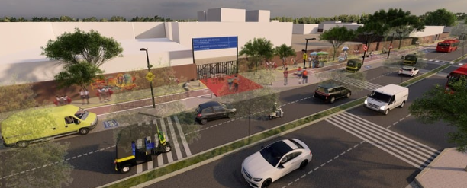

Figure 32: **Proposed Render of Maharishi Valmiki Marg in front of Govt. Boys Senior Secondary School Vishwas Nagar**

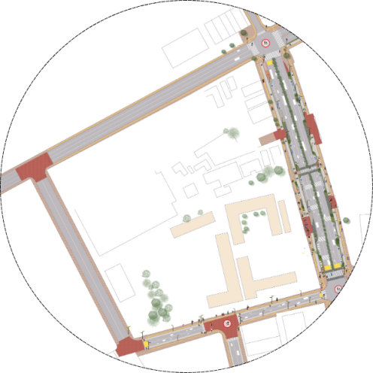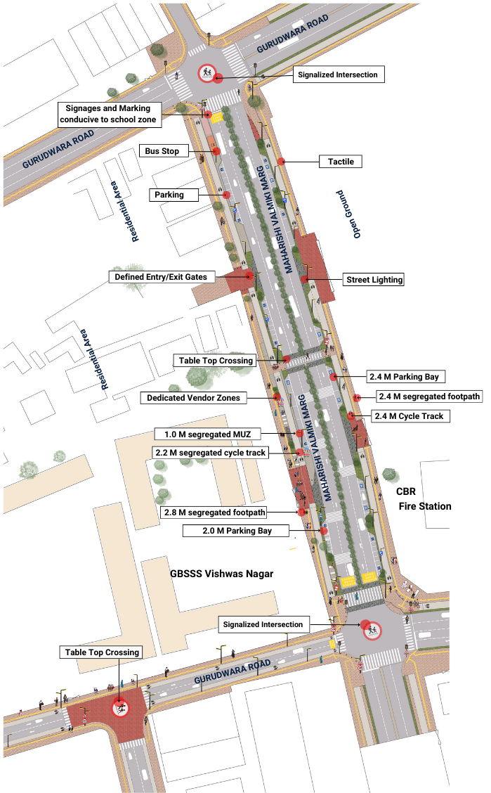

Figure 33: Proposed School Zone Plan for GBSSS Vishwas Nagar

### 

### : Summary budget estimates

| **S.No** | **Component** | **Details** | **Notes** | **Rate (per sq.m)** | **Cost (INR)** | **Cost (INR, crores)** |
| --- | --- | --- | --- | --- | --- | --- |
| **A** | **CIVIL WORK** |  |  |  |  |  |
| A.1 | Footpath (Primary, Secondary including other Flooring area) | 2.5m segregated footpath with tactile pavers in both directions | Providing and Laying of footpath 2m to 3m wide, including earthwork and base layer - PCC, GSB and finsihing material. | 2804 | 10855318 | 1.086 |
| A.2 | Raised Crossing | Signalised Intersections and traffic calming at entry/exits | Providing and laying Raised crosseing with 80 mm thk pavers blocks, and DQ stone including Earth work and Base layers- PCC (M15), RCC (M30 Design mix) & GSB etc. | 3592 | 5029411 | 0.503 |
| A.3 | Cycle Infrastructure | 2.5m segregated cycle tracks on both sides | Providing and laying cycle track (2.5mt wide segregated) inculding Earth work and Base layers- PCC (M15), RCC (M40 Design mix) & GSB etc. also thermoplastic paint for marking and cycle symbol and spring post etc | 4170 | 3336061 | 0.334 |
| A.4 | CC Items (Kerbs, Pipe, etc) | Provision of bollards, kerbs - mountable, kerb channels, etc | Providing and fixing Kerbs, Bollards , and Kerb Channel etc. in CC. |  | 1453051 | 0.145 |
| A.5 | Signages | Provision of signages as per IRC 67 for school zone & 20km/h | Providing and fixing Signage Mandatory, Cautonory and informatory sign board inculding all the fixing and labours etc. |  | 386435 | 0.039 |
| A.6 | Marking | Provision of signages as per IRC 35 for school zone & 20km/h | Providing and applying road marking strips (retro- reflective) of specified shade/ colour using hot thermoplastic material for road marking . | 814 | 1342560 | 0.134 |
| A.7 | Special Zones | Provision of seating areas, vendor spaces and play integrated with design proposal | Miscellaneous items- Provision of Sitting Bollards, CC Benches, GRC Jali, Pargola, Dustbin etc. complete items- including foundation and fixing etc. |  | 135310 | 0.014 |
| A.8 | Brick Work | -- | Brick work with common burnt clay F.P.S. (non modular) bricks of class designation 7.5 in foundation and plintin:Cement mortar 1:4 (1 cement : 4 coarse sand) | 7370.65/CUM | 94344 | 0.009 |
| A.9 | Steel Reinforncement for RCC work | -- | Steel reinforcement (in per kg) for R.C.C. work including straightening, cutting, bending, placing in position and binding all complete upto plinth level.Thermo-Mechanically Treated bars of grade Fe-500D or more | 107.85/kg | 930746 | 0.093 |
| A.10 | Pavement Surface Dressing | Pavement of Bitumen layer on existing road surface | Surface dressing on old surface with hot bitumen of grade VG - 10 | 175.10 / sq.m | 0 | 0.000 |
| A.11 | Safety Management Equipment (as per design requirement) | Provision of Delieator Post, Spring Post, Cat eye/studs etc. | Miscellaneous items for Safety Management Equipment ( as per design requirement) -Provision of Delieator Post, Spring Post, Cat eye/studs etc.- including foundation and fixing etc. |  | 10500 | 0.001 |
| A.12 | Bus Shelter | Provision of new bus shelter. |  |  | 3600000 |  |
|  | **SUB TOTAL CIVIL WORK (A)** |  |  |  | **27173735** | 2.717 |
| **B** | Drainage, Irrigation & Plumbing | Details promote catch pit along the footpath linked to existing manholes. Bell mouths are not recommended. Details to be finalised with PWD | Drainage, Irrigation & Plumbing work @ 20% of the cost of Civil work | 20% | **5434747** | 0.543 |
| **C** | Electrical Work | 5m and 10m light poles have been located alongside footpath / MUZ. Details to be finalised with PWD. | Electrical work @25% of the cost of Civil work | 25% | **6793434** | 0.679 |
| **D** | Horticulture Work | To increase green cover and shade, landscape plan to promote ground cover and trees for seasonal variation and color. Irrigation plan to be finalised with PWD. | Horticulture work @ 15% of the cost of Civil work | 15% | **4076060** | 0.408 |
| **E** | Dismantling / Demolition | -- | Dismantling work @ 15% of the cost of Civil work | 15% | **4076060** | 0.408 |
| **F** | Work Zone Safety & Management | -- | Work zone Management @ 5% of the cost of Civil work | 5% | **1358687** | 0.136 |
| **PART 1** | **SUB TOTAL PART 1 (A+B+C+D+E+F)** |  |  |  | **48912723** | 4.891 |
| **G** | Design Services & Support | -- | Design Consultancy (Preparation of Drawings, BOQ support, Work Zone plan, Site Supervision, Community Engagement & Liason, Change Management @ 2% - 8% of the cost of Civil work. | **5%** | **2445636** | 0.245 |
| **H** | Survey Cost | -- | Survey Cost (Total Station Survey, underground services, tree demarcation, girths , level differences, steps etc @ ( 80,000 per junction - 250m on each arm ) | 80000 | **80000** | 0.008 |
| **PART 2** | **SUB TOTAL PART 2 ( PART 1 + G +H)** |  |  |  | **51438359** | 5.144 |
| **J** | Contigencies '2.5% | -- | Contingencies (@2.5% ) |  | **1285959** | 0.129 |
| **I** | GST('@18%) | -- | GST @18% |  | **9490377** | 0.949 |

|  |  |  |  |  |  |  |
| --- | --- | --- | --- | --- | --- | --- |
| **FINAL** | **GRAND TOTAL(INR) (PART 2 + J + I)** |  |  |  | **62214695** | **6.221** |

**Notes:**

1. DSR 2023 has been followed for all rates. Market Rate and Costing from part PWD projects has been included for certain items. This is a preliminary estimate. Final costing to be evaluated & approved by the road owning agency.
2. Cost of Drainage, Irrigation, Plumbing has been calculated at 20% of the civil work cost.
3. Cost of Electrical Work can be calculated at 20% - 25 % of the civil work cost.
4. Cost of Horticulture has been calculated at 15% of the civil work cost.
5. Cost of Dismantling has been calculated at 15% of the civil work cost.
6. Cost of Work Zone Management has been calculated at 5% of the civil work cost.
7. Cost for Design Support can range from 2% - 8%, and can vary from site to site. This should include Technical Assistance on drawings, 3D supports, Site Supervision, Change management.
8. Bus Shelter has been calculated at 18 L per shelter; can be changed as per design specific cost.
9. In case of new items specific to design, please add relevant rows in detail budget estimation and include the same in the budget summary under relevant head.

**Link to the appendix report: <https://tripc.iitd.ac.in/publication/report>**

